

BIKE RENTAL COUNT

DATA SCIENCE PROJECT

Nithin Reddy Jaydi

**Contents**

## Introduction

|  |  |
| --- | --- |
| 1.1 Problem Statement | 2 |
| 1.2 Dataset | 2 |
| 1.3 Exploratory Data Analysis | 3 |
| 1.4 Data Understanding | 4 |

1. **Methodology**

|  |  |  |
| --- | --- | --- |
| 2.1 Data Pre Processing | | 8 |
| 2.1.1 | Missing Value Analysis | 8 |
| 2.1.2 | Outlier Analysis | 9 |
| 2.1.3 | Feature Selection | 10 |
| 2.1.4 | Feature Scaling | 11 |
| 2.2 Model Development | | 12 |
| 2.2.1 | Decision Tree | 12 |
| 2.2.2 Hyper Parameter Tuning | | 12 |
| 2.2.3 Random Forest | | 12 |
| 2.2.4 | Linear Regression | 12 |
| 2.2.5 Gradient Boosting | | 13 |
| **3. Conclusion** | | |
| 3.1 Model Evaluation | | 13 |
| 3.2 Model Selection | | 14 |

|  |  |
| --- | --- |
| **4. Coding** |  |
| 4.1 R Coding | 14 |
| 4.2 Python Coding | 23 |
|  |  |

1. **Introduction**

### Problem Statement

##### The objective of this Case is to Predication of bike rental count on daily based on the environmental and seasonal settings.

* 1. **Dataset**

Sample Dataset-

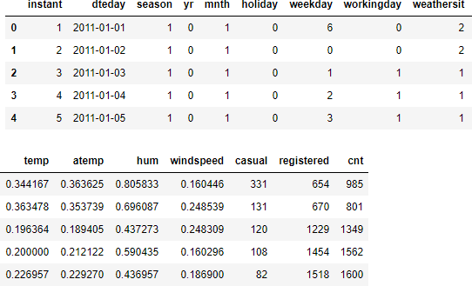

Dataset has 16 variables in which 15 variables are independent and 1 (‘cnt’) is dependent variable. And we have to prepare a model to predict the count of bikes on daily basis based on environmental. In the dataset target variable is continuous in nature, so this is a regression problem.

##### Attribute Information:

1. instant: Record index
2. dteday: Date
3. season: Season (1:springer, 2:summer, 3:fall, 4:winter)

**4.** yr: Year (0: 2011, 1:2012)

1. mnth: Month (1 to 12)
2. holiday: weather day is holiday or not (extracted fromHoliday Schedule)
3. weekday: Day of the week
4. workingday: If day is neither weekend nor holiday is 1, otherwise is 0.
5. weathersit: (extracted fromFreemeteo)

**i:** Clear, Few clouds, Partly cloudy, Partly cloudy

**ii:** Mist + Cloudy, Mist + Broken clouds, Mist + Few clouds, Mist

**iii:** Light Snow, Light Rain + Thunderstorm + Scattered clouds, Light Rain +

Scattered clouds

**iv:** Heavy Rain + Ice Pallets + Thunderstorm + Mist, Snow + Fog

1. temp: Normalized temperature in Celsius. The values are derived via (t-t_min)/(t_max-t_min),

t_min=-8, t_max=+39 (only in hourly scale)

1. atemp: Normalized feeling temperature in Celsius. The values are derived via (t-t_min)/(t_maxt_min), t_min=-16, t_max=+50 (only in hourly scale)
2. hum: Normalized humidity. The values are divided to 100 (max)
3. windspeed: Normalized wind speed. The values are divided to 67 (max)
4. casual: count of casual users
5. registered: count of registered users
6. cnt: count of total rental bikes including both casual and registered

### Exploratory Data Analysis

Exploratory Data Analysis (EDA) is an approach to analysing data sets to summarize their main characteristics. In the given data set there are 16 variables and data types of all variables are object, float64 or int64. There are 731 observations and 16 columns in our data set.

|  |  |  |
| --- | --- | --- |
| • | **Instant** | **int64** |
| • | **Dteday** | **object** |
| • | **Season** | **int64** |
| • | **Yr** | **int64** |
| • | **Mnth** | **int64** |
| • | **Holiday** | **int64** |
| • | **Weekday** | **int64** |
| • | **Workingday** | **int64** |
| • | **Weathersit** | **int64** |
| • | **Temp** | **float64** |
| • | **Atemp** | **float64** |
| • | **Hum** | **float64** |
| • | **Windspeed** | **float64** |
| • | **Casual** | **int64** |
| • | **Registered** | **int64** |
| • | **Cnt** | **int64** |

* + - **dtype: object**

From EDA we have concluded that there are 7 continuous variable and 9 categorical variable in nature.

##### Continuous variables in dataset-

|  |  |  |
| --- | --- | --- |
| • | Temp | float64 |
| • | Atemp | float64 |
| • | Hum | float64 |
| • | Windspeed | float64 |
| • | Casual | int64 |
| • | Registered | int64 |
| • | Cnt | int64 |

**Categorical variables in dataset-**

|  |  |  |
| --- | --- | --- |
| • | **instant** | **int64** |
| • | **dteday** | **object** |
| • | **season** | **int64** |
| • | **yr** | **int64** |
| • | **mnth** | **int64** |
| • | **holiday** | **int64** |
| • | **weekday** | **int64** |
| • | **workingday** | **int64** |
| • | **weathersit** | **int64** |

From EDA we have concluded the number of unique values in each variables.

|  |  |  |
| --- | --- | --- |
| • | **instant** | **731** |
| • | **dteday** | **731** |
| • | **season** | **4** |
| • | **yr** | **2** |
| • | **mnth** | **12** |
| • | **holiday** | **2** |
| • | **weekday** | **7** |
| • | **workingday** | **2** |
| • | **weathersit** | **3** |
| • | **temp** | **499** |
| • | **atemp** | **690** |
| • | **hum** | **595** |
| • | **windspeed** | **650** |
| • | **casual** | **606** |
| • | **registered** | **679** |
| • | **cnt** | **696** |

In EDA we have seen that some of variables are not important for proceed further as these are irrelevant variable in our dataset so we will remove them before processing the data. we have dropped variable **‘Instant’** as it is index in dataset, also removed **‘dteday’** variable as it is not Time-Series data, so we dropped it, also there are two variables **‘casual’** and **‘registered’,** because these two variables sum is our target variable, so these are not of our use. so we dropped them.

In EDA we rename some of variables in our dataset before proceeding further, for better understanding the dataset. After renaming of variables the updated variables name are as-

* + - **season**
    - **year**
    - **month**
    - **holiday**
    - **weekday**
    - **workingday**
    - **weather**
    - **temperature**
    - **humidity**
    - **windspeed**
    - **count**

### Data Understanding

For better understanding of data, here we have plotted some visualization for the variables.

1. 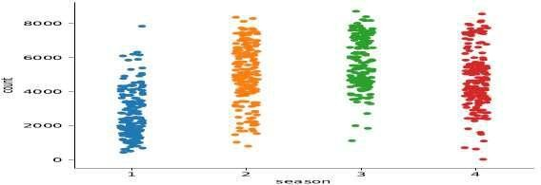From season plot in figure-1.4.1 we can see that season 2,3 and 4 have more bike count as compare to season 1. the daily bike count for these season was between 4000 to 8000.

*figure-1.4.1*

1. Below plot figure-1.4.2 is for month wise count of bikes, so this tells us that the bike counts are higher between month 4 to month 10 as comapre to other months.

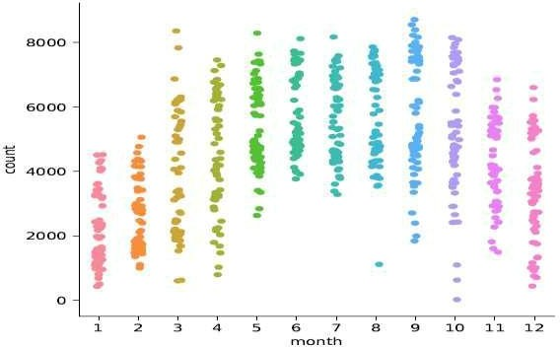

*figure-1.4.2*

1. Below Plot Figure-1.4.3 is between holiday and count, from this plot we can clearly say count of rented bikes are higher on holiday.

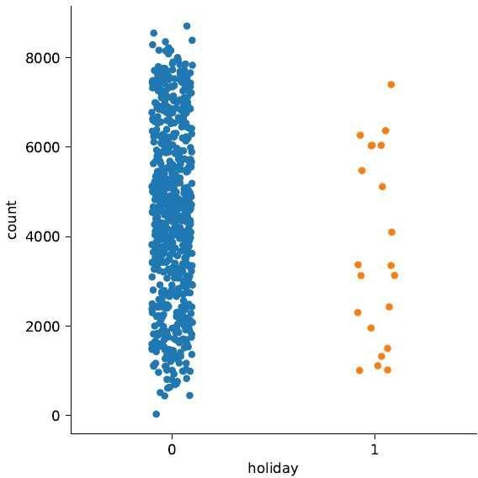

*figure-1.4.3*

1. In weather-1 in figure-1.4.4 the count of bikes is good as compare to other weather.

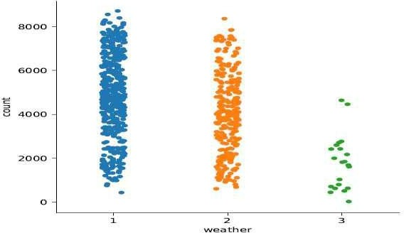

*figure-1.4.4*

1. 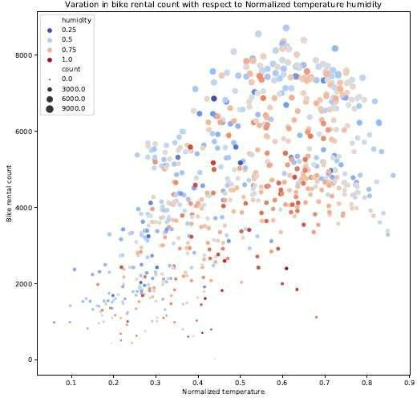Below plot figure-1.4.5 is for count bike with respect to normalized temperature and normalized humidity, from this we can see that count is maximum when temperature 0.4 to 0.7 and humidity below 0.75

*figure-1.4.5*

1. The below plot figure-1.4.6 is for bike count with respect to Normalized Temperature and Normalized Humidity, from this plot it is clear that count is higher when the temp is 0.5 to 0.7 and windspeed below 0.15 and humidity less than 0.75

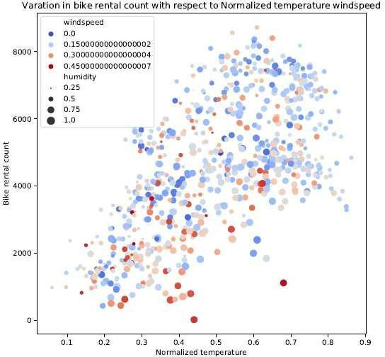

*figure-1.4.6*

1. 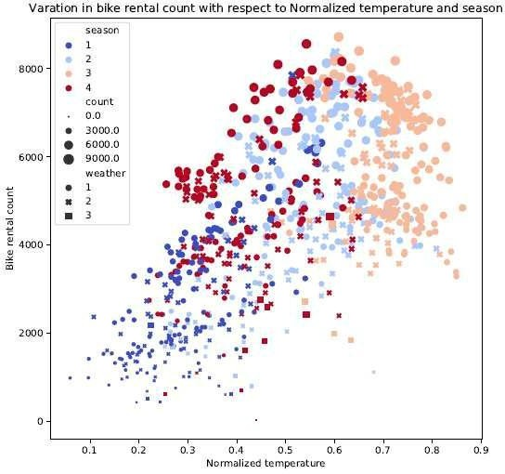Below Plot figure-1.4.7 is plotted for count of bikes with respect to temperature, weather and humidity, and we have found that the count is maximum when temperature is between 0.5 to 0.7, and in season 2 and 3.

*figure-1.4.7*

## Methodology

Before feeding the data to the model we need to clean the data and convert it to a proper format. It is the most crucial part of data science. In this we have to apply different pre-processing techniques to clean the data and to convert it into proper format.

### Data Pre Processing

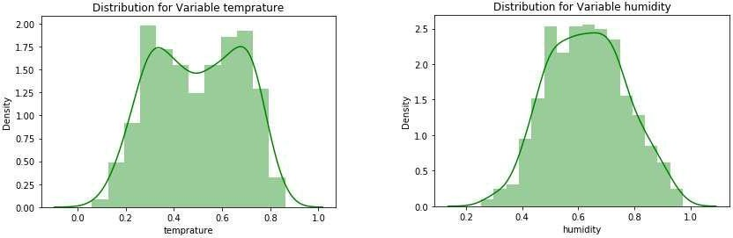Any predictive modelling requires that we look at the data before we start modelling. Looking at data refers to exploring the data, cleaning the data as well as visualizing the data through graphs and plots. This is often called as Exploratory Data Analysis. To star t this process we will first try and look at all the probability distributions of the variables. Most analysis like regression, require the data to be normally distributed. We can visualize in the below figure 2.1.1 and figure 2.1.2 the probability distributions or probability density functions of the variables.

*figure-2.1.1*

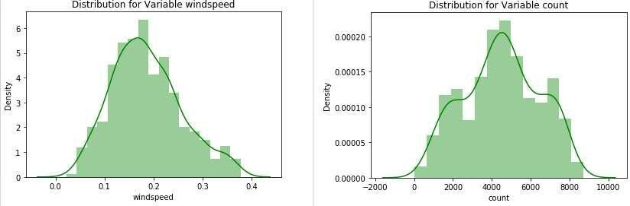

*figure-2.1.2*

#### 2.2.1 Missing Value Analysis

In statistics, *missing data*, or *missing values*, occur when no *data value* is stored for the variable in an observation. If a columns has more than 30% of data as missing value either we ignore the entire column or we ignore those observations. In the given data there is no any missing value. So we do not need to impute missing values.

##### Missing Values in Dataset-

|  |  |  |
| --- | --- | --- |
| • | **season** | **0** |
| • | **year** | **0** |
| • | **month** | **0** |
| • | **holiday** | **0** |
| • | **weekday** | **0** |
| • | **workingday** | **0** |
| • | **weather** | **0** |
| • | **temprature** | **0** |

|  |  |  |
| --- | --- | --- |
| • | **atemp** | **0** |
| • | **humidity** | **0** |
| • | **windspeed** | **0** |
| • | **count** | **0** |

* + 1. **Outlier Analysis**

One of the other steps of pre-processing is to check the presence of outliers. Outliers are those values which are present in the dataset with a abnormal distance from most part of values. The issue of outlier occurs only in Continuous variables. Here to check the outlier in our dataset, we used a classic approach to visualize outliers, that is Boxplot Method.

In figure 2.1.2.1 and figure 2.1.2.2 we have plotted the boxplots of the continuous variables with respect to target variable **count**, and detect the outliers by visualization.

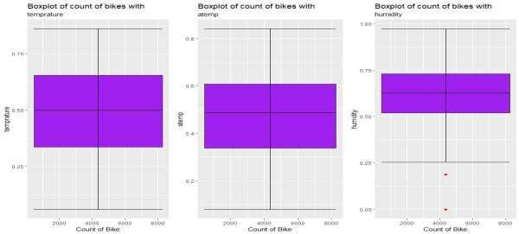

*figure-2.1.2.1*

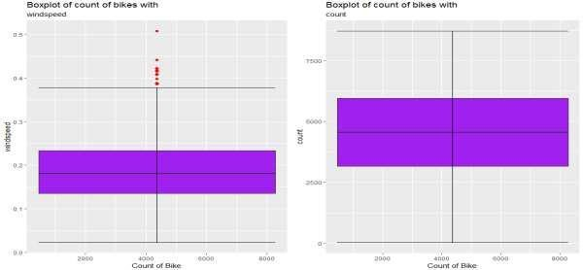

*figure-2.1.2.2*

From the boxplot almost all the variables **except “windspeed” and “humidity”** does not have outliers. From the boxplot visualization .We have converted the outliers (data beyond minimum and maximum values) as NA i.e. missing values and fill them by **Median** imputation method.

#### Feature Selection

Before performing any type of modeling we need to assess the importance of each predictor variable in our analysis. There is a possibility that many variables in our analysis are not important at all to the problem of prediction. Selecting subset of relevant columns for the model construction is known as Feature Selection. We cannot use all the features because some features may be carrying the same information or irrelevant information which can increase overhead. To reduce overhead we adopt feature selection technique to extract meaningful features out of data. This in turn helps us to avoid the problem of multi collinearity. In this project we have selected **Correlation Analysis** for numerical variable and **ANOVA** (Analysis of variance) for categorical variables.

##### Correlation Analysis plot (figure-2.1.3.1) for continuous variables-

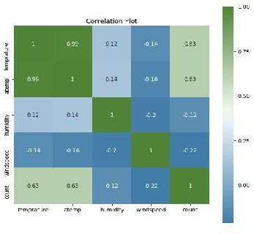

|  |  |  |  |  |  |
| --- | --- | --- | --- | --- | --- |
| *figure-2.1.3.1* | | | | | |
| **ANOVA Analysis for categorical variables-** | | | | | |
| **sum_sq** | **df** |  | **F** |  | **PR(>F)** |
| **season** | **4.52E+08** | **1** | **143.967653** | | **2.13E-30** |
| **Residual** | **2.29E+09** | **729** | **NaN** |  | **NaN** |
| **sum_sq** | **df** |  | **F** |  | **PR(>F)** |
| **year** | **8.80E+08** | **1** | **344.890586** | | **2.48E-63** |
| **Residual** | **1.86E+09** | **729** | **NaN** |  | **NaN** |
| **sum_sq** | **df** |  | **F** |  | **PR(>F)** |
| **month** | **2.15E+08** | **1** | **62.004625** | | **1.24E-14** |
| **Residual** | **2.52E+09** | **729** | **NaN** |  | **NaN** |
| **sum_sq** | **df** |  | **F** |  | **PR(>F)** |
| **holiday** | **1.28E+07** | **1** | **3.421441** | **0** | **0.064759** |
| **Residual** | **2.73E+09** | **729** | **NaN** |  | **NaN** |
| **sum_sq** | **df** |  | **F** |  | **PR(>F)** |
| **weekday** | **1.25E+07** | **1** | **3.331091** | **0** | **0.068391** |
| **Residual** | **2.73E+09** | **729** | **NaN** |  | **NaN** |
| **sum_sq** | **df** |  | **F** |  | **PR(>F)** |

|  |  |  |  |  |  |
| --- | --- | --- | --- | --- | --- |
| **workingday** | **1.02E+07** | **1** | **0** | **2.736742** | **0.098495** |
| **Residual** | **2.73E+09** | **729** | **0** | **NaN** | **NaN** |
| **sum_sq** | **df** |  | **F** |  | **PR(>F)** |
| **weather** | **2.42E+08** | **1** |  | **70.729298** | **2.15E-16** |
| **Residual** | **2.50E+09** | **729** | **NaN** |  | **NaN** |

From correlation analysis we have found that **temperature** and **atemp** has high correlation (>0.9), so we have excluded the **atemp** column, and from ANOVA analysis we have found that in categorical variables **Holiday, weekday and working day** have the pr(>0.05), so we excluded them.

After Correlation Analysis we have remaining variables are-

##### Continuous variables in dataset-

|  |  |  |
| --- | --- | --- |
| • | temprature | float64 |
| • | humidity | float64 |
| • | windspeed | float64 |
| • | count | int64 |

**Categorical variables in dataset-**

|  |  |  |
| --- | --- | --- |
| • | **season** | **int64** |
| • | **year** | **int64** |
| • | **month** | **int64** |
| • | **weather** | **int64** |

* + 1. **Feature Scaling**

**Feature scaling** is a method used to standardize the range of independent variables or features of data. In data processing, it is also known as data normalization and is generally performed during the data preprocessing step. In some machine learning algorithms, objective functions will not work properly without normalization. For example, the majority of classifiers calculate the distance between two points by the Euclidean distance. If one of the features has a broad range of values, the distance will be governed by this particular feature. Therefore, the range of all features should be normalized so that each feature contributes approximately proportionately to the final distance. Since as in given dataset for continuous variables data is already Normalized, so we do not need to scale the data.

|  |  |  |  |
| --- | --- | --- | --- |
|  | **temperature** | **humidity** | **windspeed** |
| **count** | 731.000000 | 731.000000 | 731.000000 |
| **mean** | 0.495385 | 0.629354 | 0.186257 |
| **std** | 0.183051 | 0.139566 | 0.071156 |
| **min** | 0.059130 | 0.254167 | 0.022392 |
| **25%** | 0.337083 | 0.522291 | 0.134950 |
| **50%** | 0.498333 | 0.627500 | 0.178802 |
| **75%** | 0.655417 | 0.730209 | 0.229786 |
| **max** | 0.861667 | 0.972500 | 0.378108 |

### Model Development

After Data pre-processing the next step is to develop a model using a train or historical data

Which can perform to predict accurate result on test data or new data. Here we have tried with different model and will choose the model which will provide the most accurate values.

#### Decision Tree

Decision Tree is a supervised machine learning algorithm, which is used to predict the data for classification and regression. It accepts both continuous and categorical variables. A decision tree is a decision support tool that uses a tree-like graph or model of decisions and their possible consequences, including chance event outcomes, resource costs, and utility. Each branch connects nodes with “and” and multiple branches are connected by “or”. Extremely easy to understand by the business users. It provides its output in the form of rule, which can easily understood by a non-technical person also.

#### Hyper parameter Tuning-

In statistics, hyperparameter is a parameter from a prior distribution; it captures the prior belief before data is observed. In any machine learning algorithm, these parameters need to be initialized before training a model. Choosing appropriate hyperparameters plays a crucial role in the success of good model. Since it makes a huge impact on the learned model. For example, if the learning rate is too low, the model will miss the important patterns in the data. If it is high, it may have collisions.

we used two techniques of Hyperparameter in our model-

* + - * Random Search
      * Grid Search

##### Random Search-

Random search is a technique where random combinations of the hyperparameters are used to find the best solution for the built model. In this search pattern, random combinations of parameters are considered in every iteration. The chances of finding the optimal parameter are comparatively higher in random search because of the random search pattern where the model might end up being trained on the optimised parameters without any aliasing.

##### Grid Search-

Grid search is a technique which tends to find the right set of hyperparameters for the particular model. Hyperparameters are not the model parameters and it is not possible to find the best set from the training data. Model parameters are learned during training when we optimise a loss function using something like a gradient descent. In this tuning technique, we simply build a model for every combination of various hyperparameters and evaluate each model. The model which gives the highest accuracy wins. The pattern followed here is similar to the grid, where all the values are placed in the form of a matrix. Each set of parameters is taken into consideration and the accuracy is noted. Once all the combinations are evaluated, the model with the set of parameters which give the top accuracy is considered to be the best.

#### Random Forest

Random Forest is an ensemble technique that consists of many decision trees. The idea behind Random Forest is to build n number of trees to have more accuracy in dataset. It is called random forest as we are building n no. of trees randomly. In other words, to build the decision trees it selects randomly n no of variables and n no of observations. It means to build each decision tree on random forest we are not going to use the same data. The higher no of trees in the random forest will give higher no of accuracy, so in random forest we can go for multiple trees. It can handle large no of independent variables without variable deletion and it will give the estimates that what variables are important. The RMSE value and R^2 value for our project in R and Python are –

#### Linear Regression

Linear Regression is one of the statistical method of prediction. It is most common predictive analysis algorithm. It uses only for regression, means if the target variable is continuous than we can use linear regression machine learning algorithm.

#### 2.2.4 Gradient Boosting

Gradient boosting is a machine learning technique for regression and classification problems, It produces a prediction model in the form of an ensemble of weak learner models and produce a strong learner with less misclassification and higher accuracy. It feed the error from one decision tree to another decision tree and generates a strong classifier or Regressor.

## Conclusion

In methodology we have done data cleaning and then applied different-different machine learning algorithms on the data set to check the performance of each model, now in conclusion we will finalize the model of Bike Rental Count.

### Model Evaluation

In the previous chapter we have applied four algorithms on our dataset and calculate the Mean absolute percentage error (MAPE) and R- Squared Value for all the models. MAPE is a measure of prediction accuracy of a forecasting method. It measures accuracy in terms of percentage. R-squared is basically explains the degree to which input variable explain the variation of the output. In simple words R- squared tells how much variance of dependent variable explained by the independent variable. It is a measure if goodness of f it in regression line. Value of R-squared between 0-1, where 0 means independent variable unable to explain the target variable and 1 means target variable is completely explained by the independent variable. So, lower values of MAPE and higher value of R-Squared Value indicate better fit of model.

##### Here, the result of each model in Python and R as- Python Result-

**R-Result-**

|  |  |  |  |  |  |  |
| --- | --- | --- | --- | --- | --- | --- |
| Model |  | MAPE_Train |  | MAPE_Test | R.Squared_Train | R.Squared_Test |
| Decision Tree for Regression | | 56.30014552 |  | 23.70970208 | 0.793974257 | 0.752194789 |
| Random Search in Decision Tree | | 56.30014552 |  | 23.70970208 | 0.793974257 | 0.752194789 |
| Gird Search in Decision Tree | | 56.30014552 |  | 23.70970208 | 0.793974257 | 0.752194789 |
| Random Forest | | 23.31578346 |  | 17.41229633 | 0.967674325 | 0.866706395 |
| Random Search in Random Forest | | 25.44288679 |  | 17.52099336 | 0.96787762 | 0.865370081 |
| Grid Search in Random Forest | | 24.88492838 |  | 17.61271901 | 0.964533357 | 0.866318841 |
| Linear Regression | | 47.40023298 |  | 16.87102913 | 0.900758595 | 0.851246285 |
| Gradient Boosting | | 37.02665525 |  | 17.24280795 | 0.900758595 | 0.851246285 |
| Random Search in Gradient Boosting |  | 25.00204653 |  | 17.60370181 | 0.968267213 | 0.863821245 |
| Grid Search in Gradient Boosting | | 25.64630592 |  | 17.40282785 | 0.964533357 | 0.866318841 |

* 1. **Model Selection**

From the observation of all **MAPE** and **R-Squared** Value we have concluded that **Random Forest** has minimum value of MAPE (**20.42%)** and it’s **R-Squared** Value is also maximum (**0.88**).Means, By Random forest algorithm predictor are able to explain 88% to the target variable on the test data. The MAPE value of Test data and Train does not differs a lot this implies that it is not the case of overfitting.

## Coding

In this section we are attaching the coding of R and Python which we developed for our model.

### 4.1.R Coding

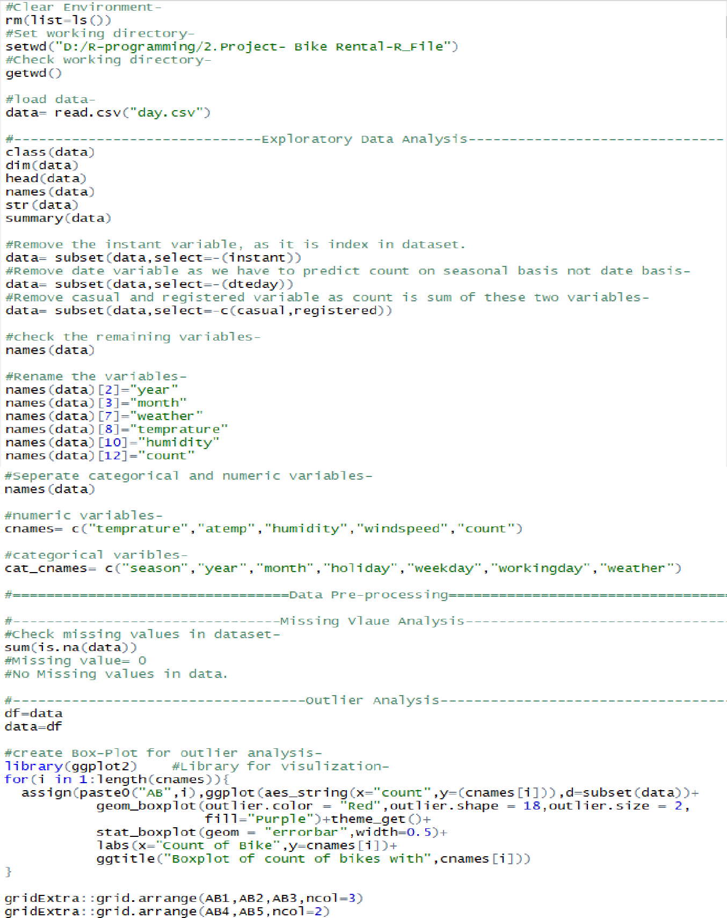

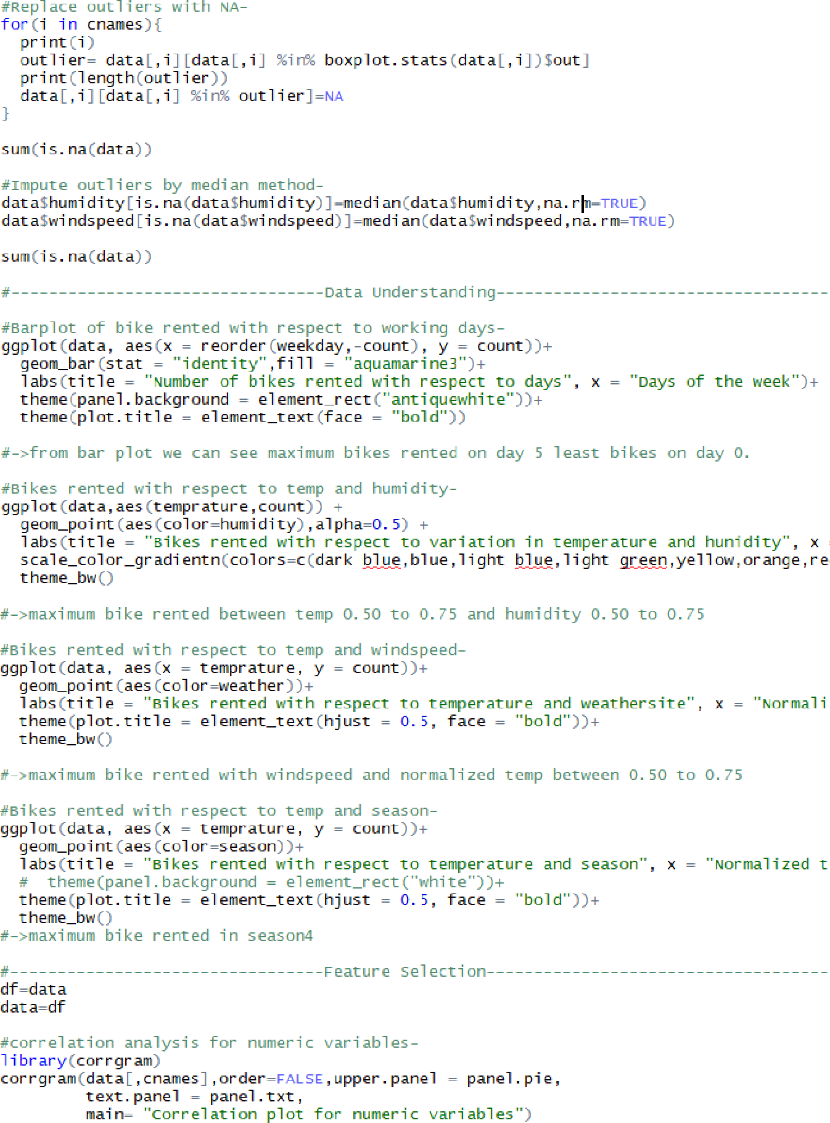

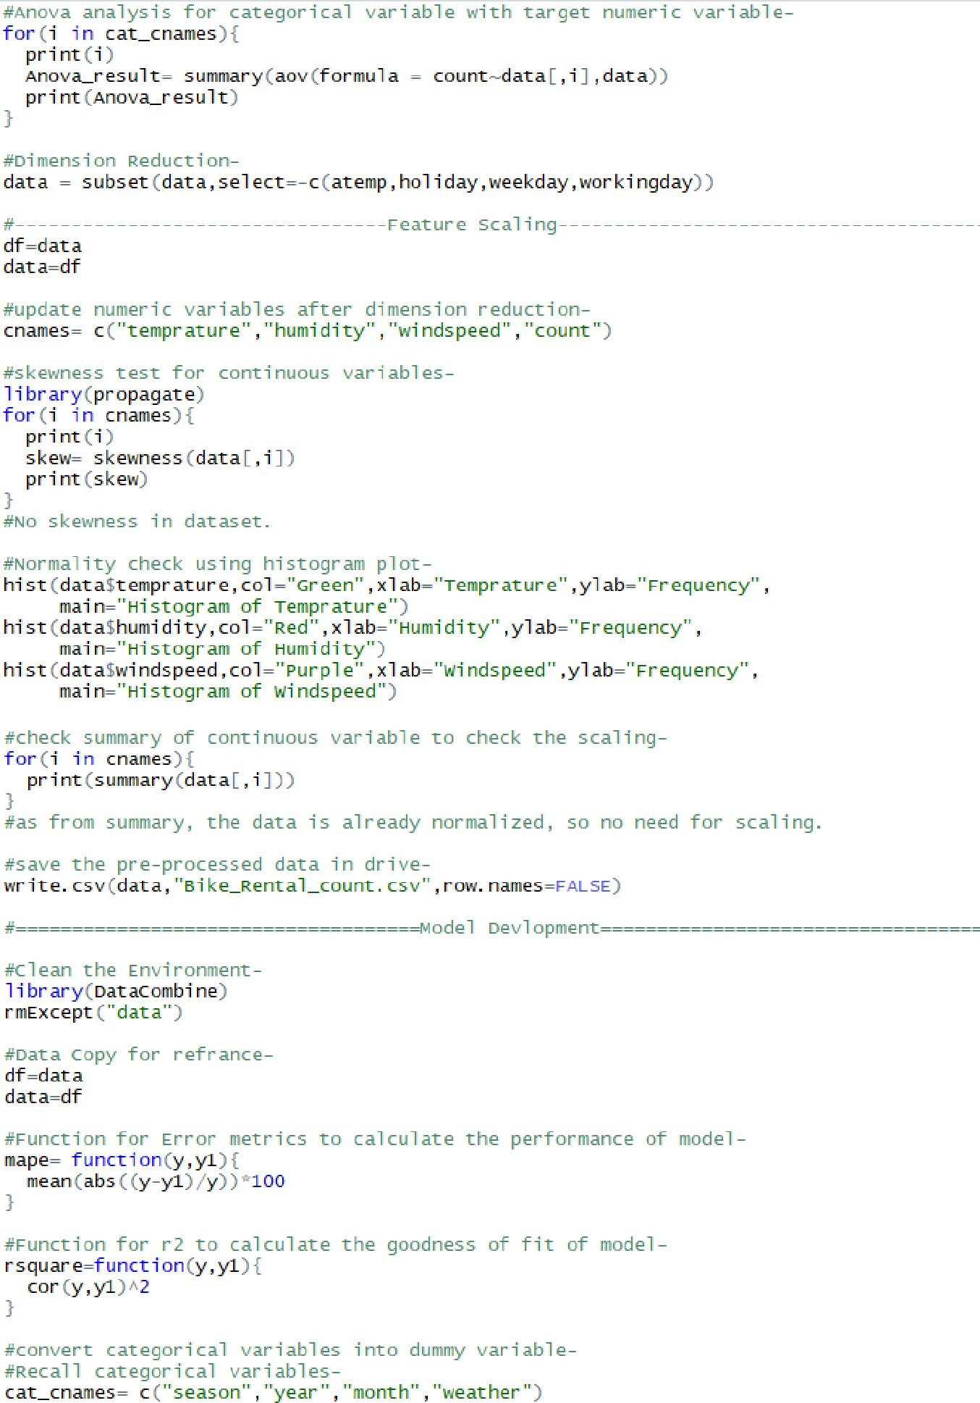

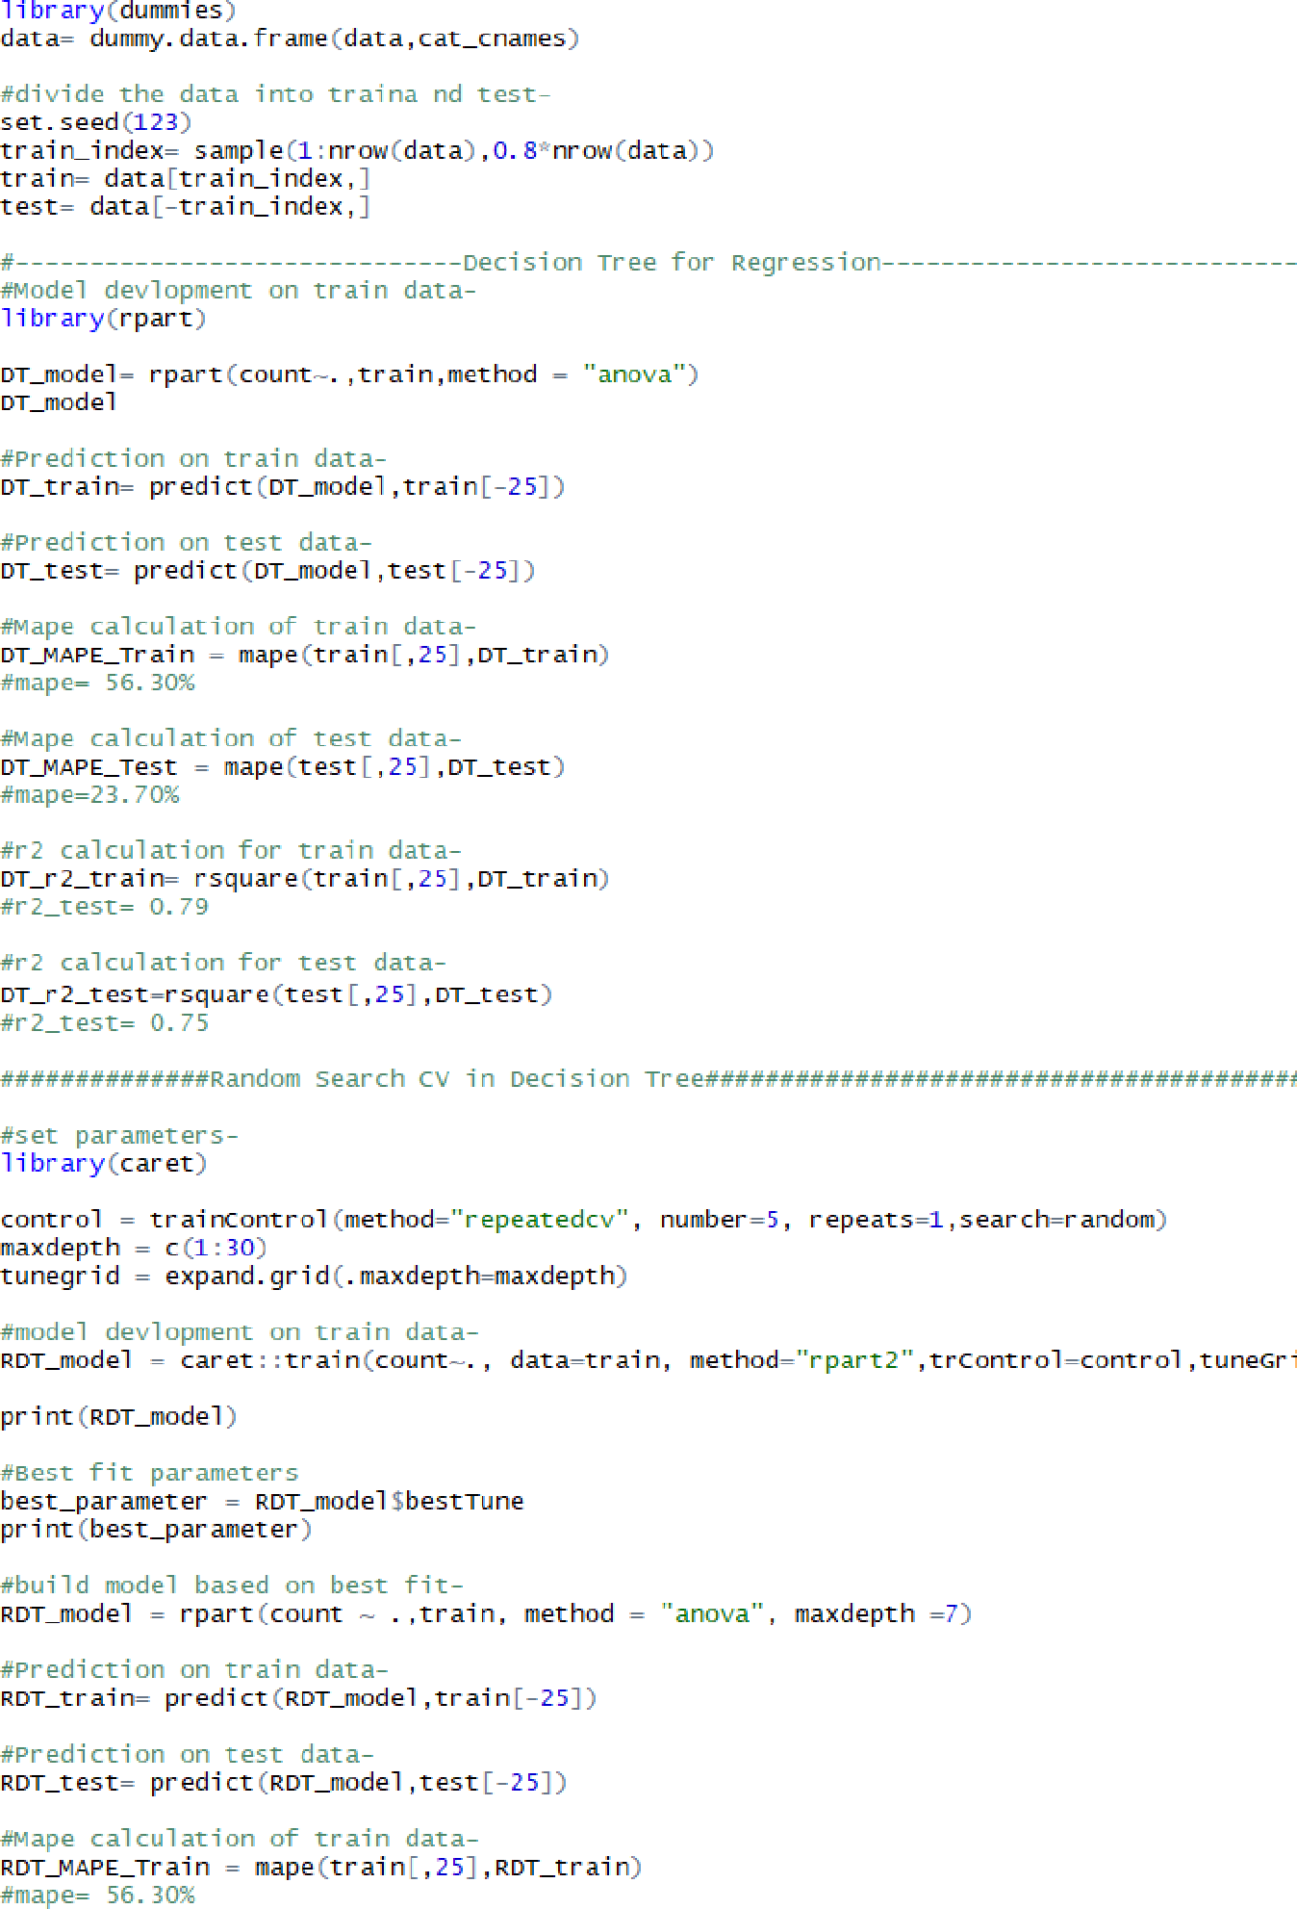

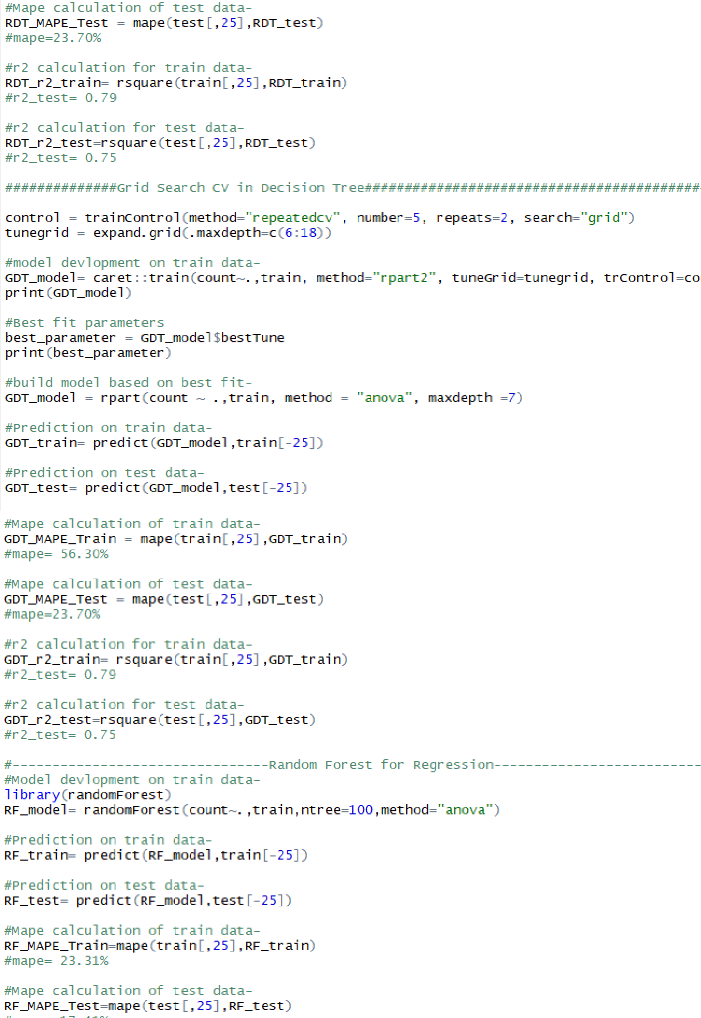

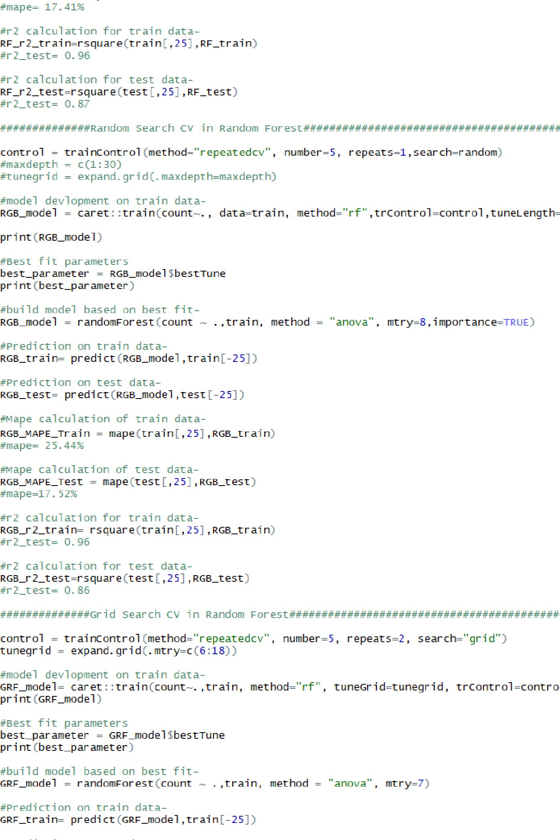

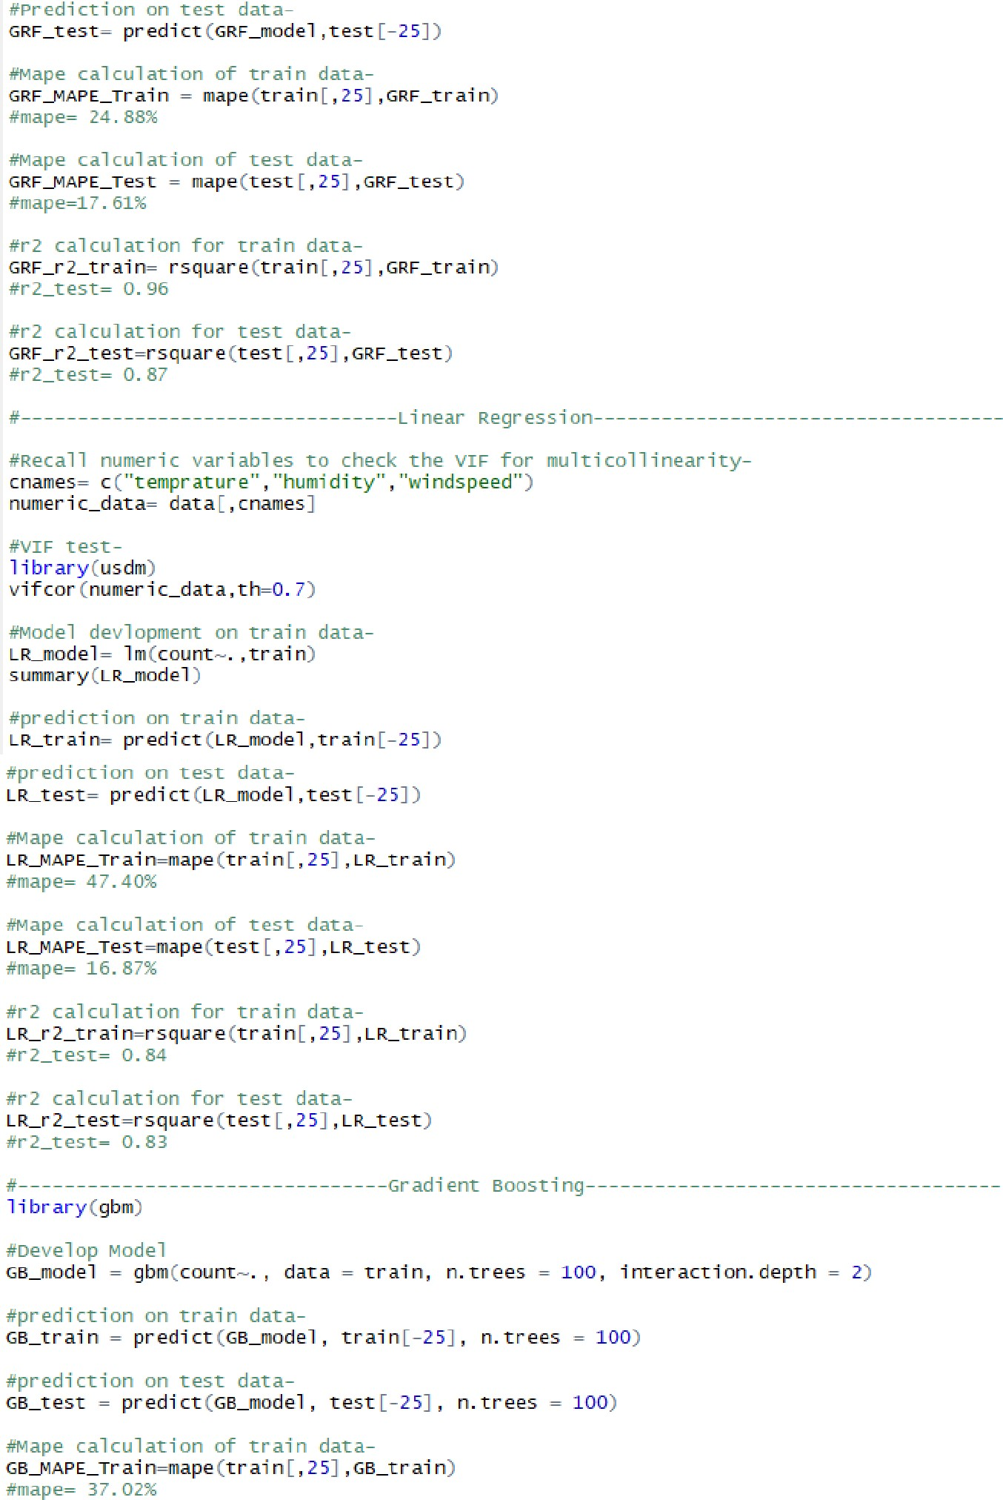

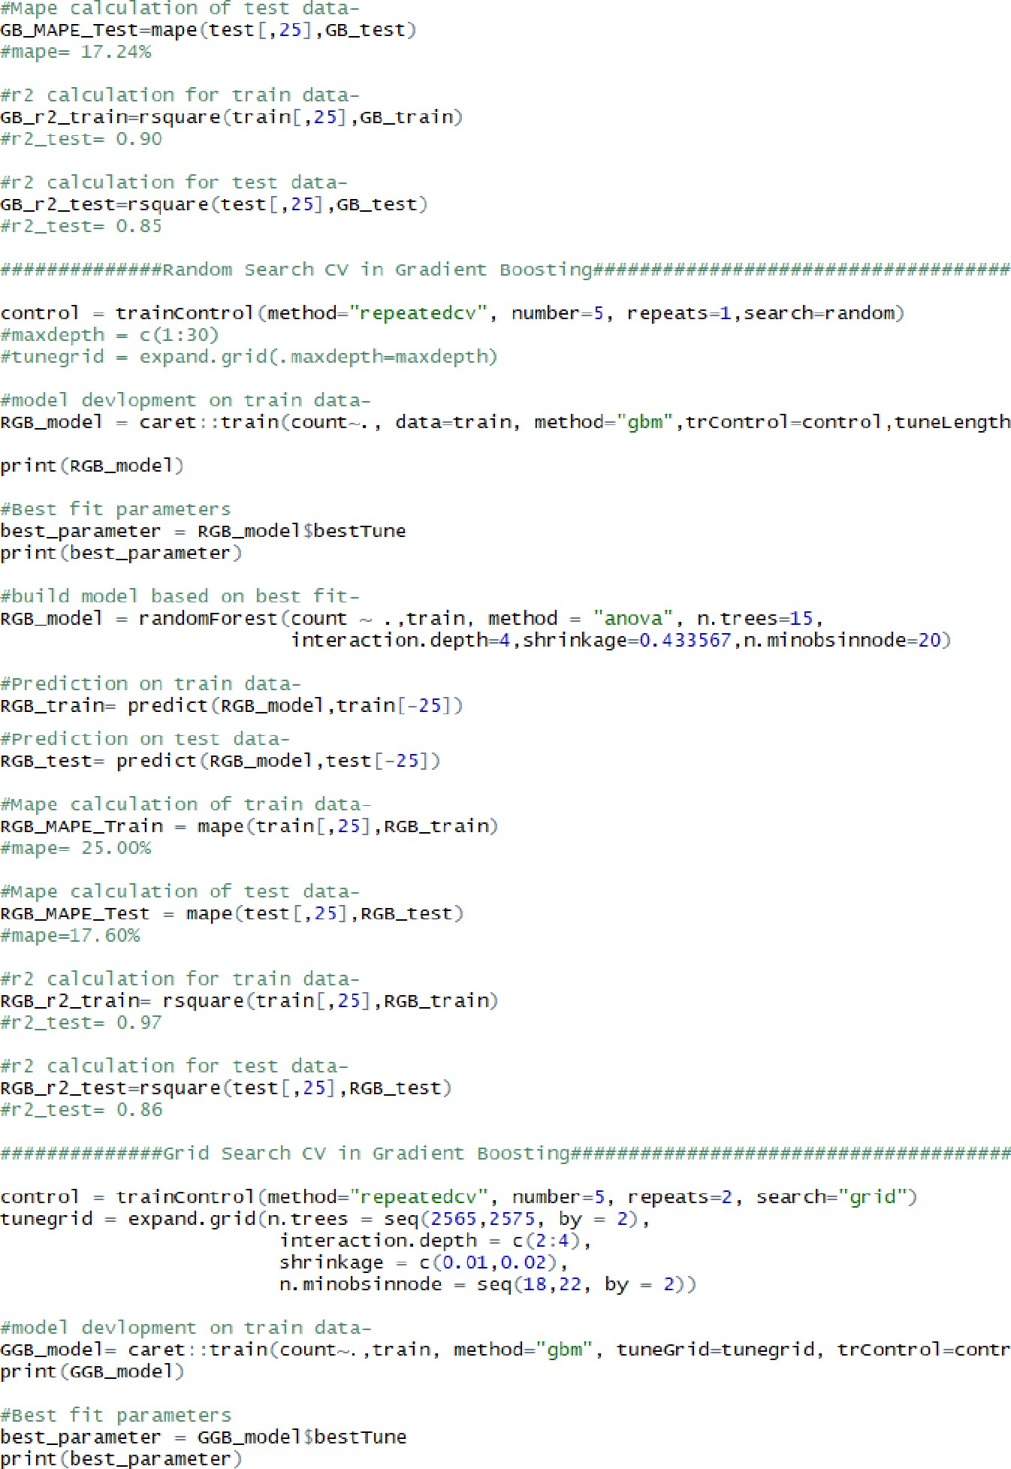

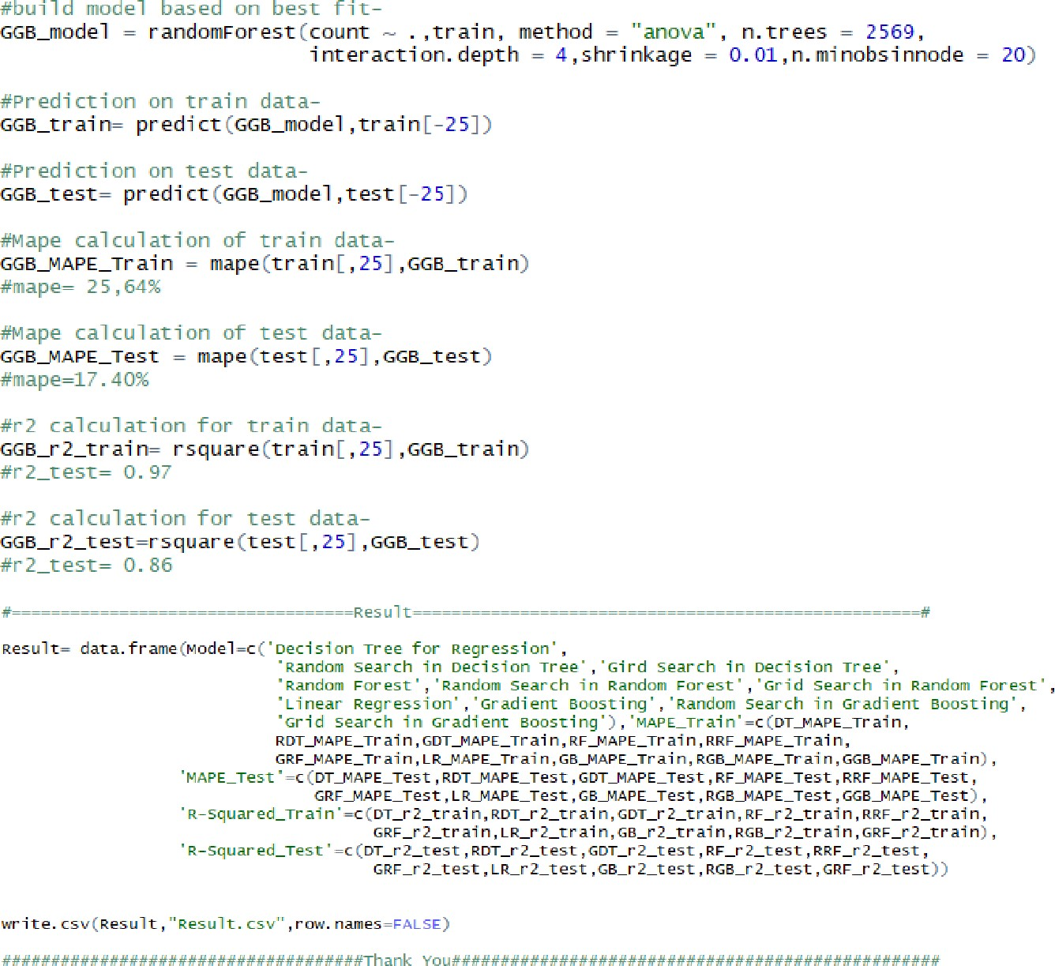

* 1. 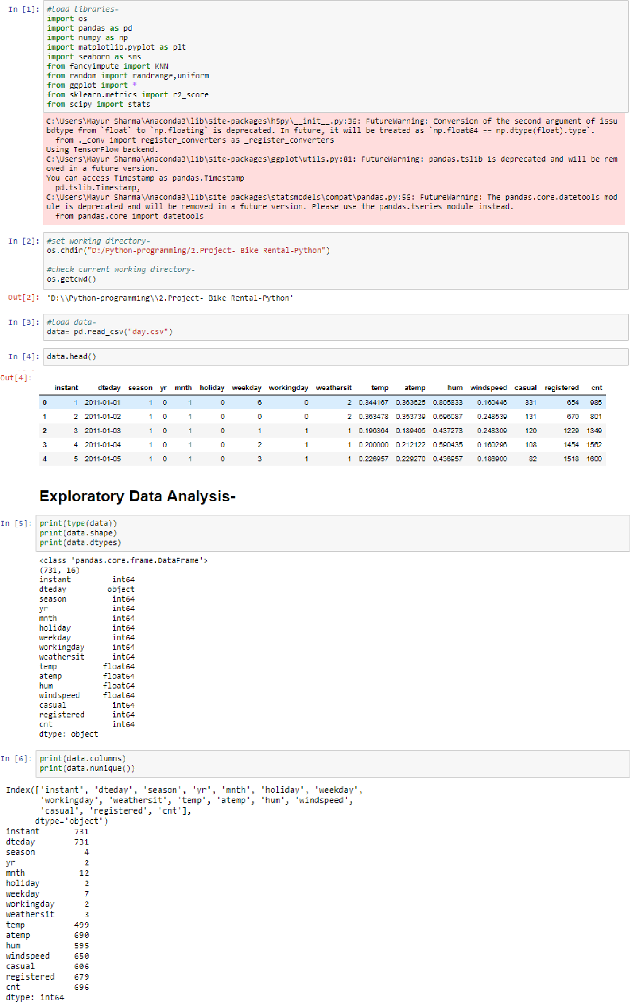**Python Coding**

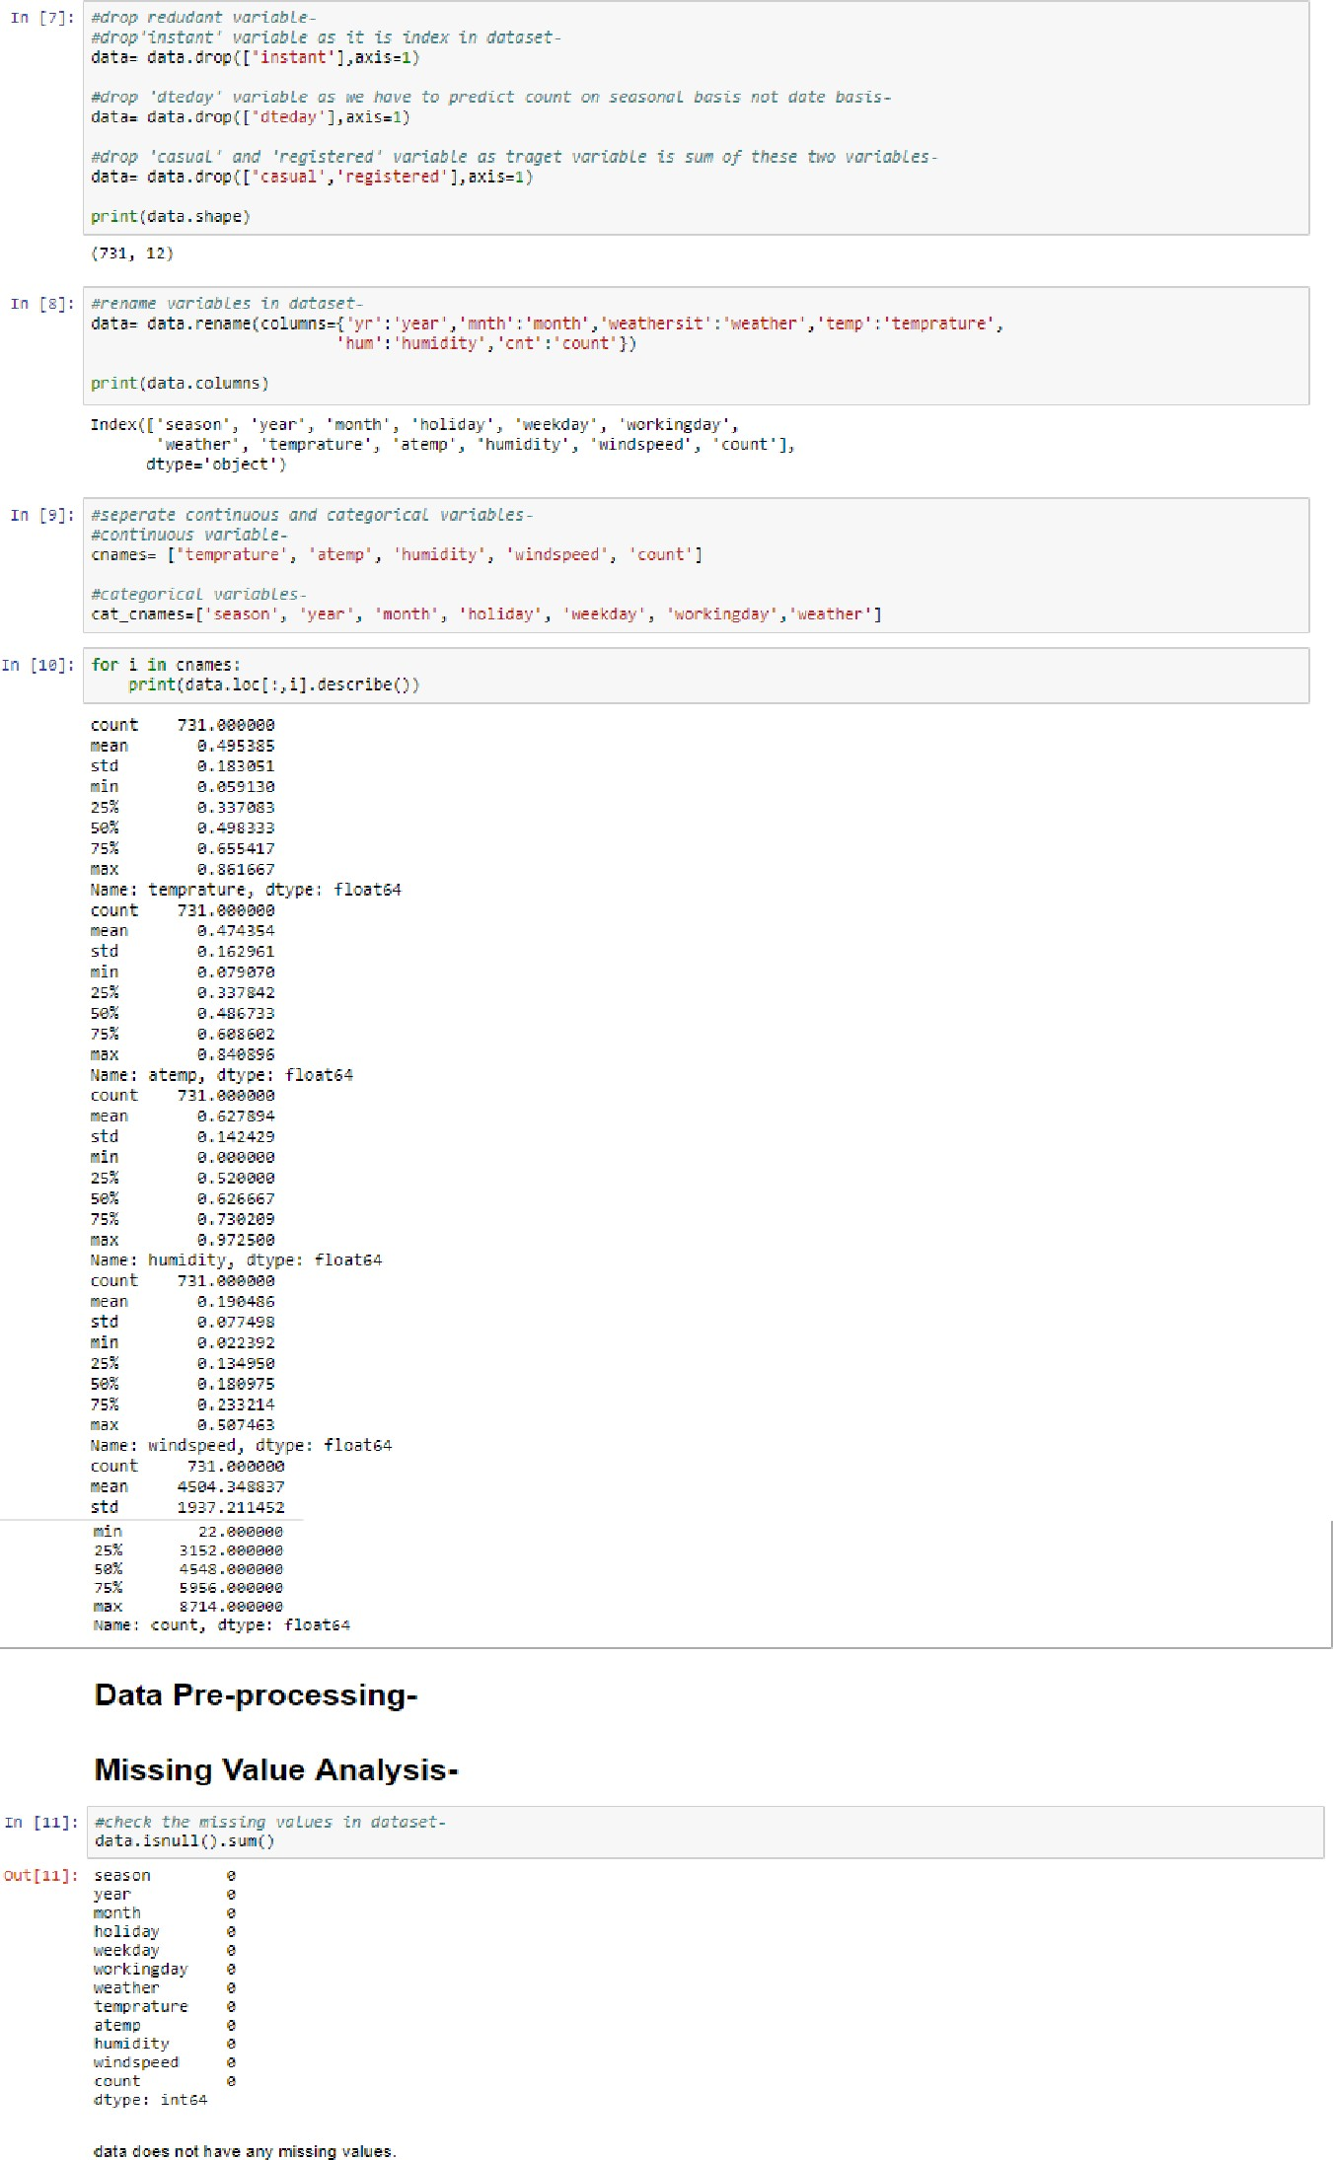

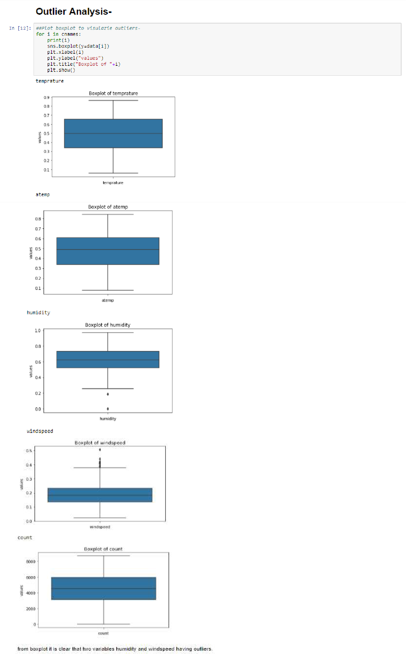

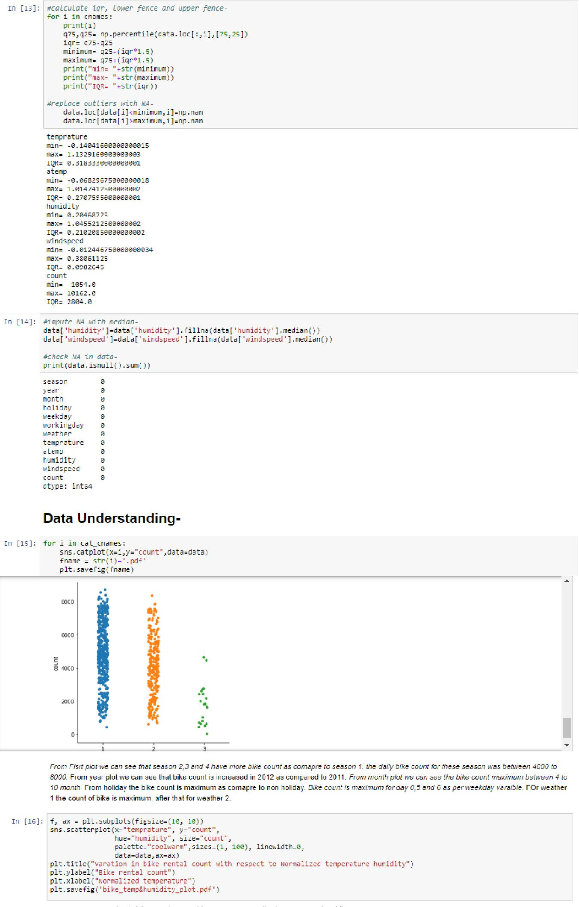

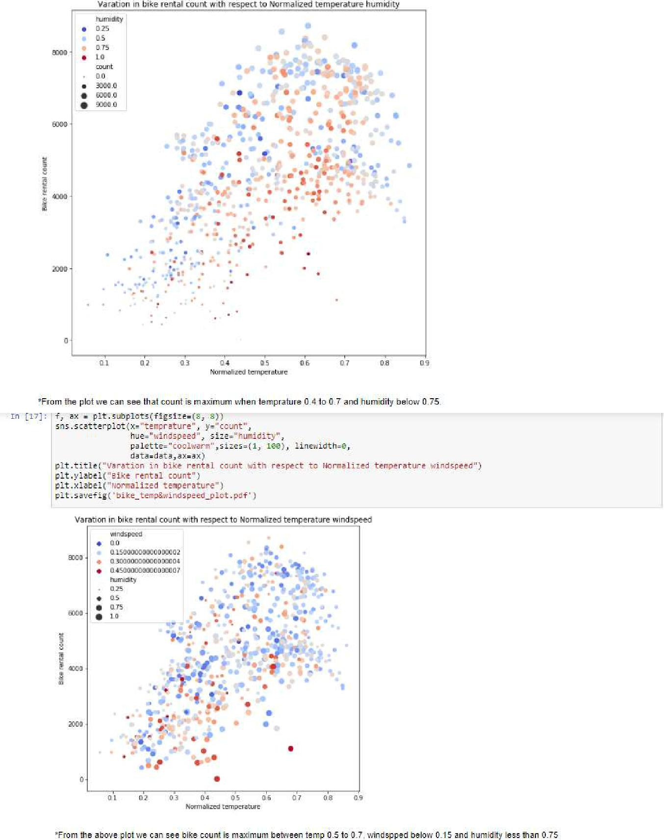

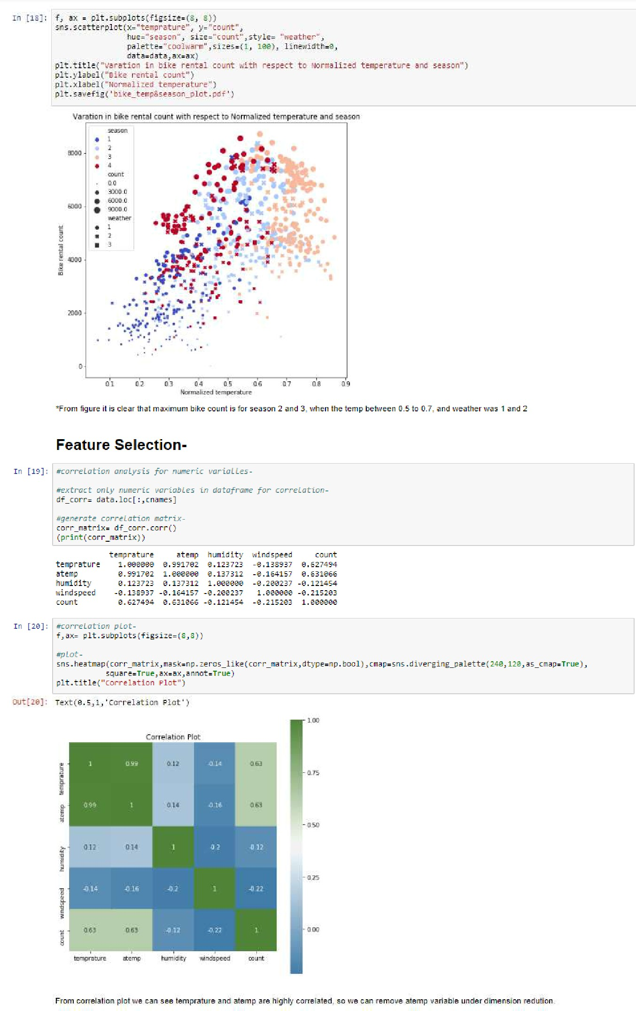

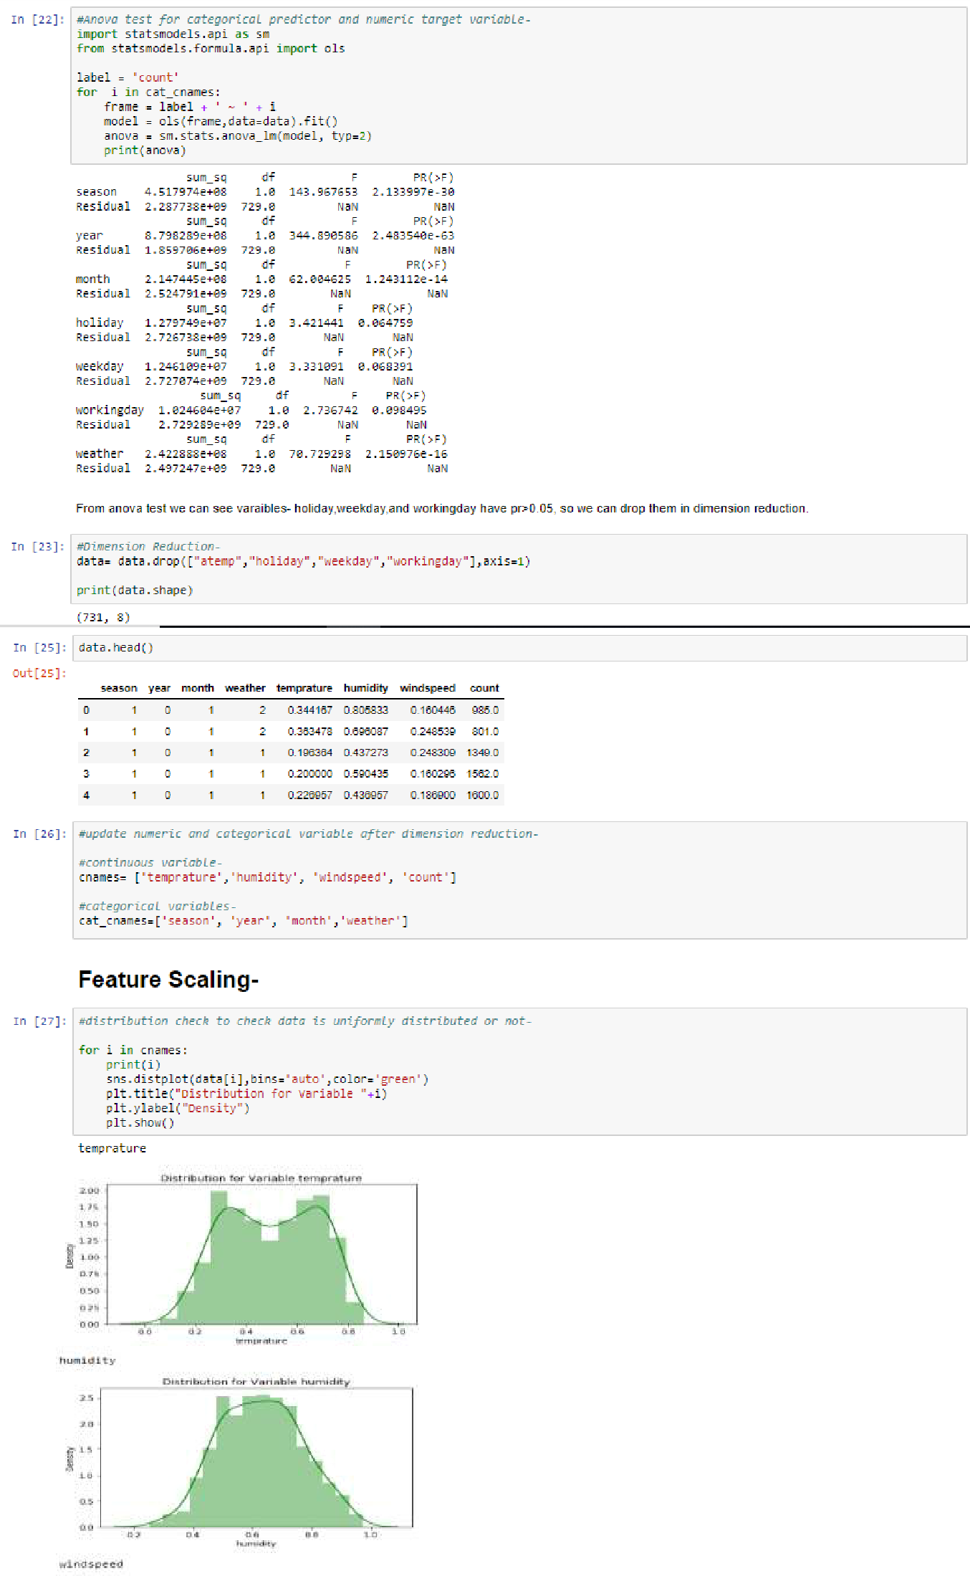

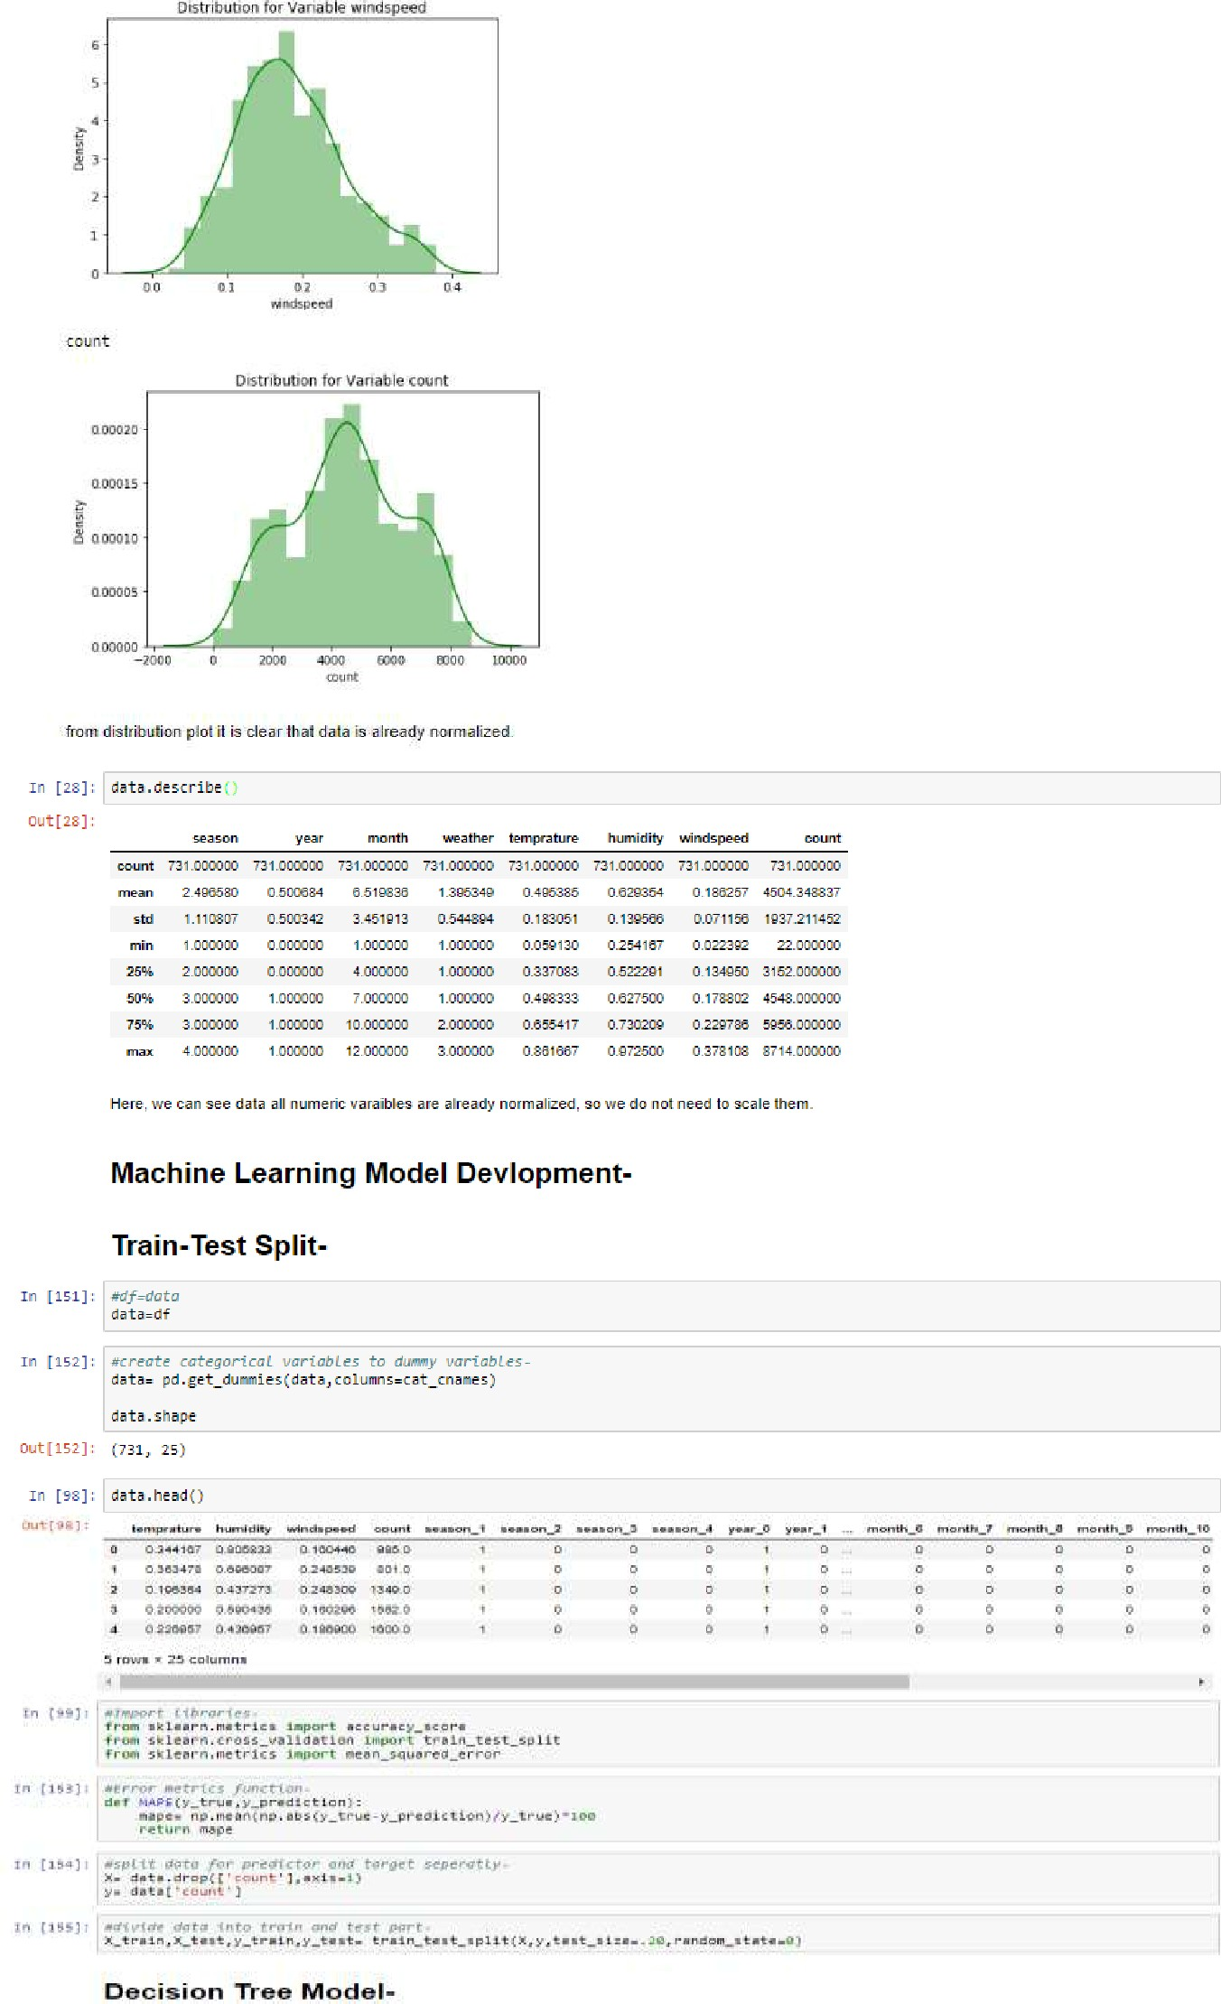

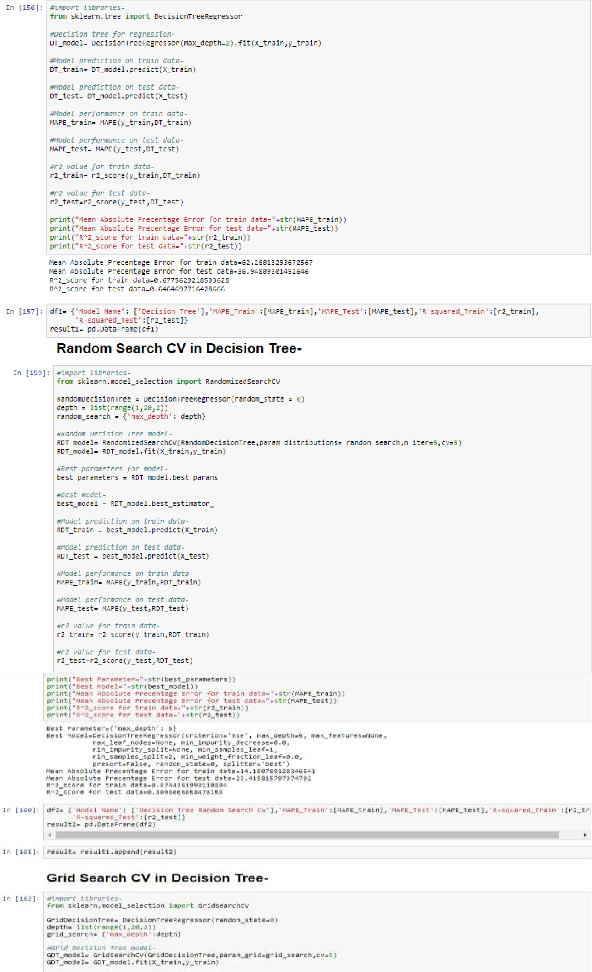

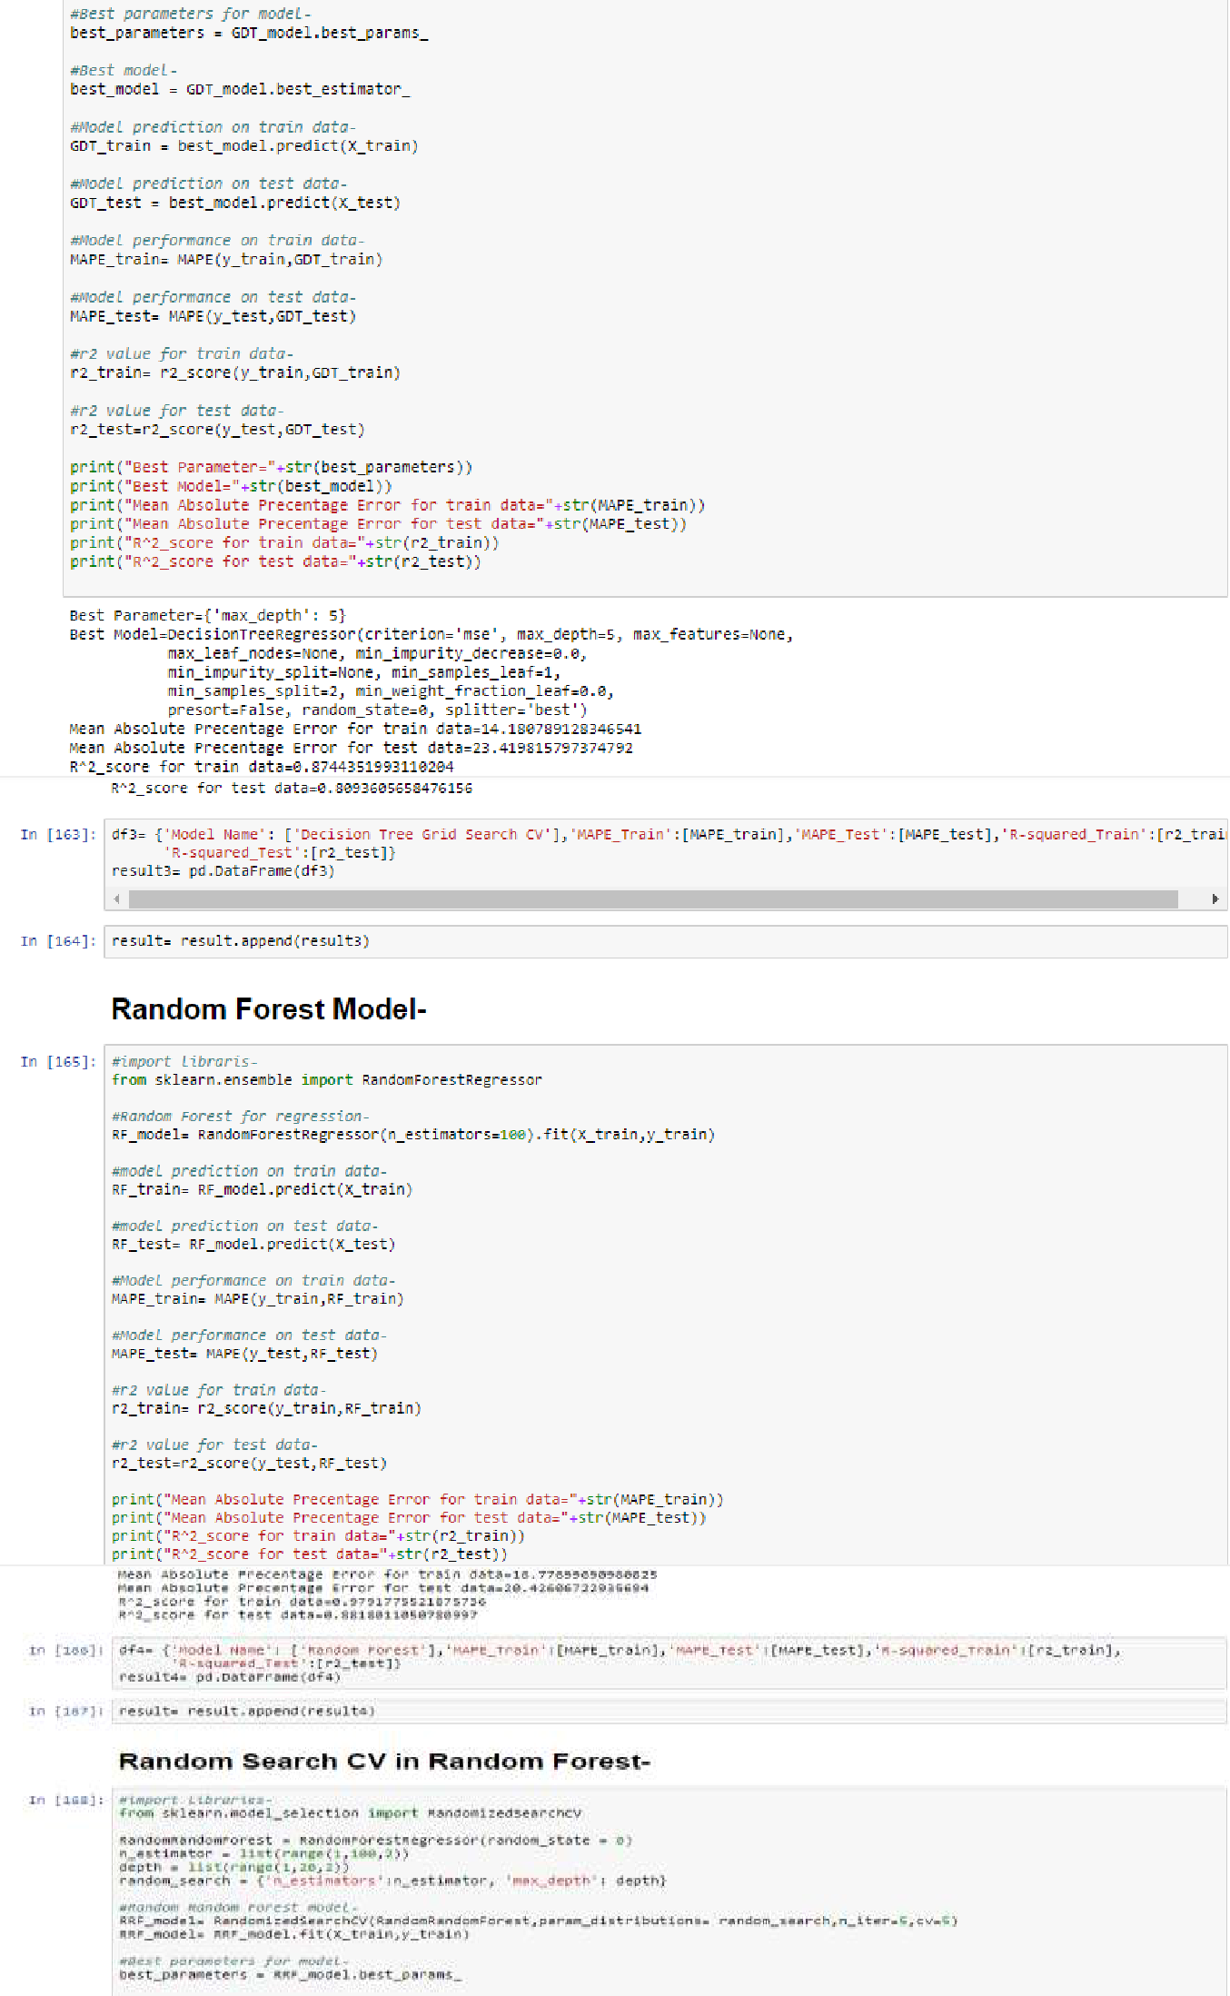

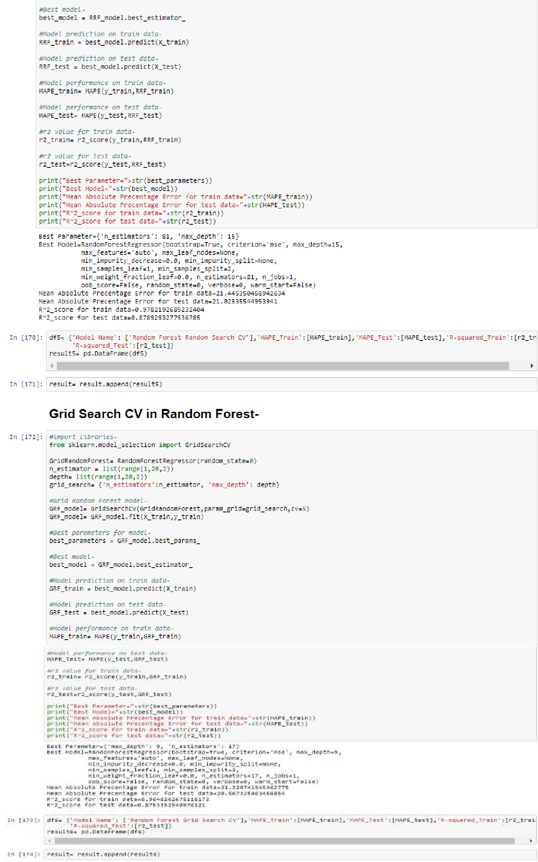

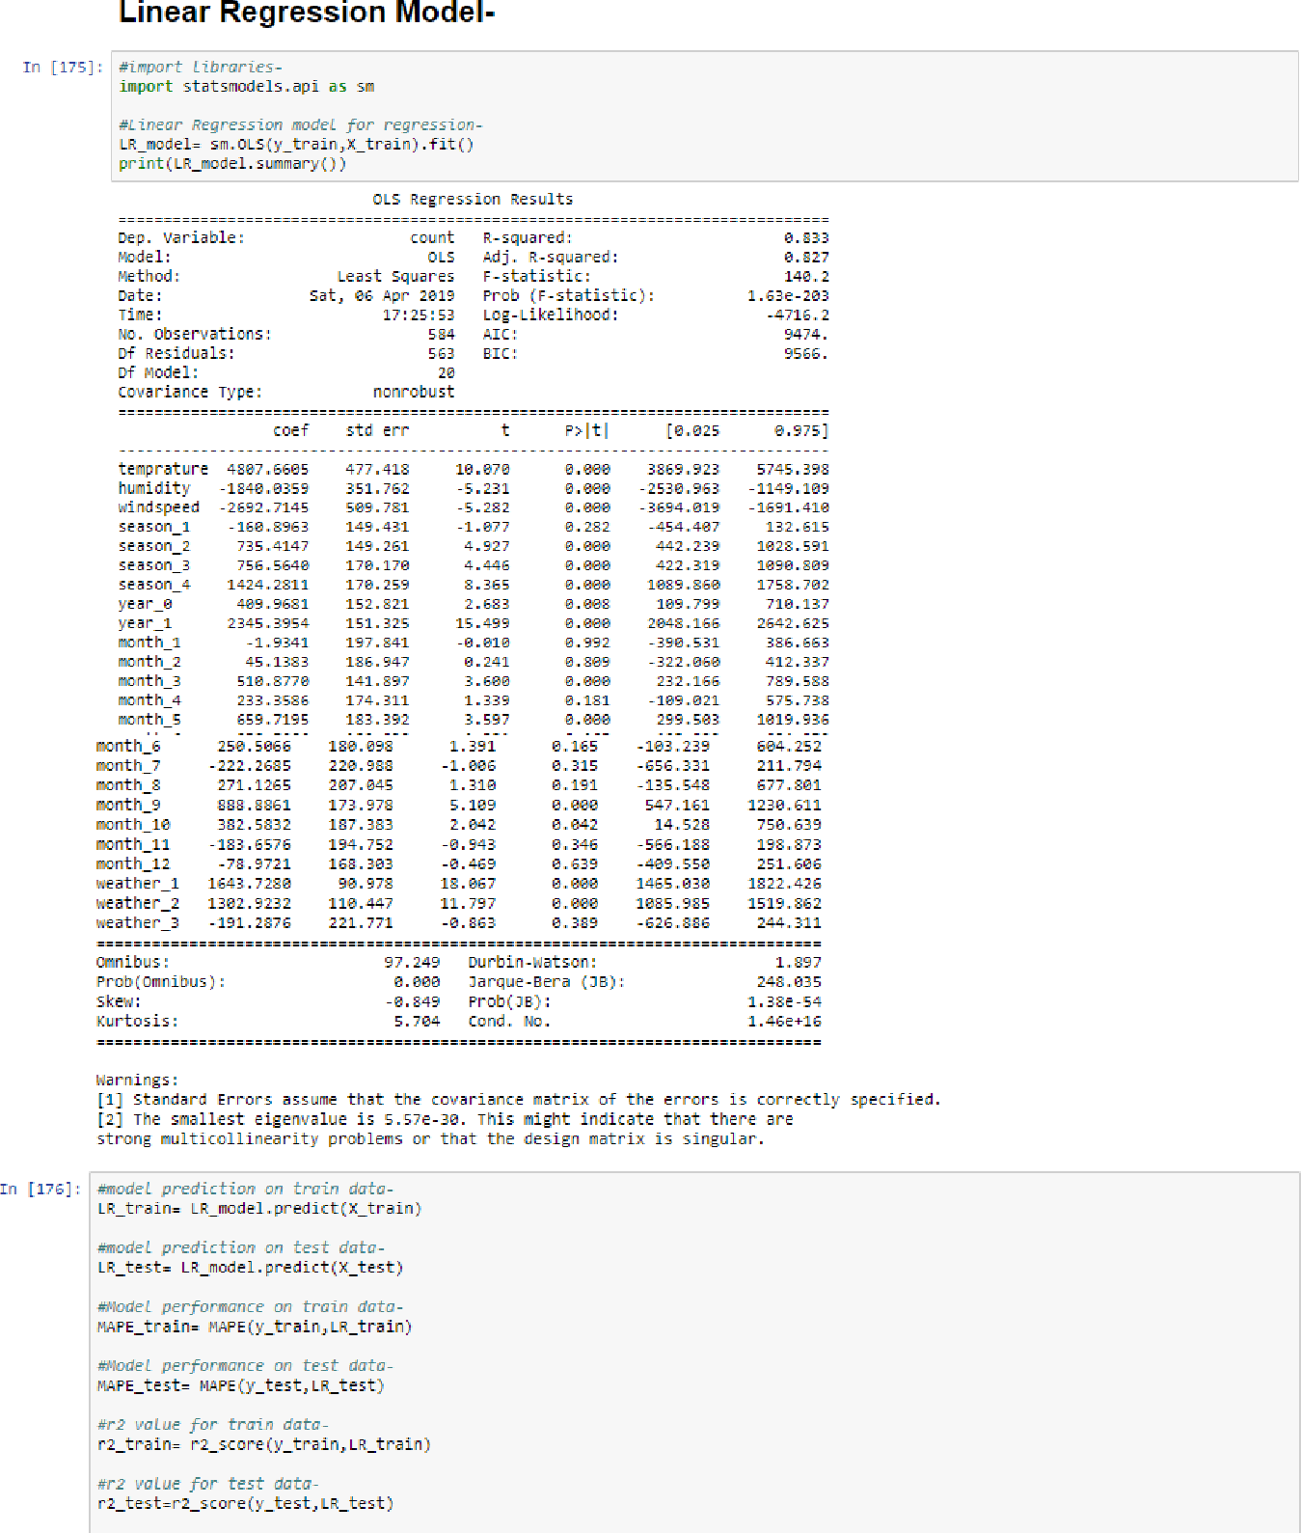

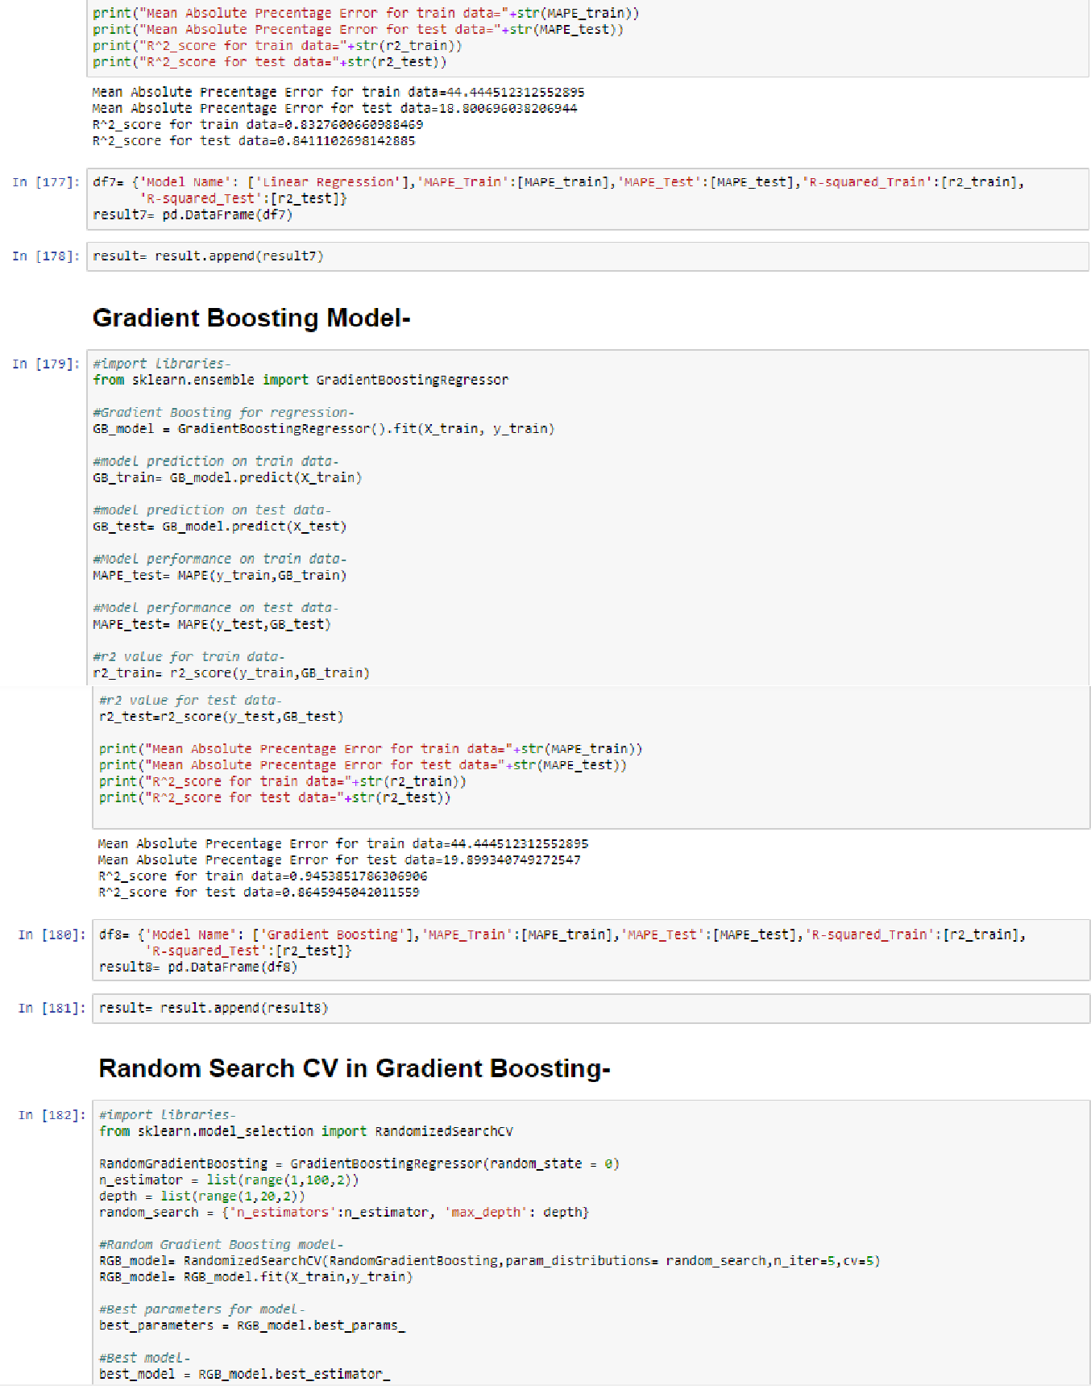

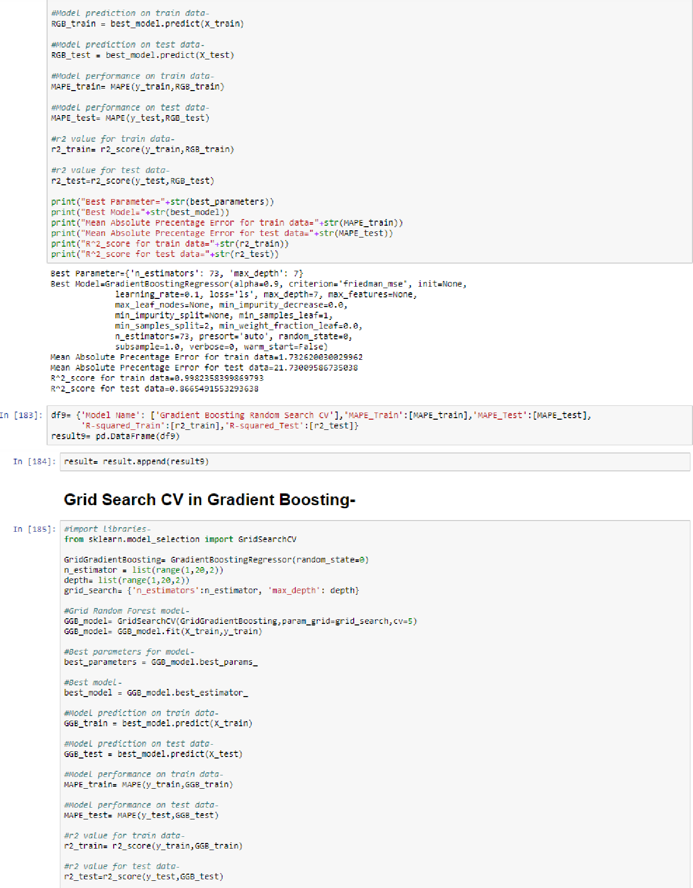

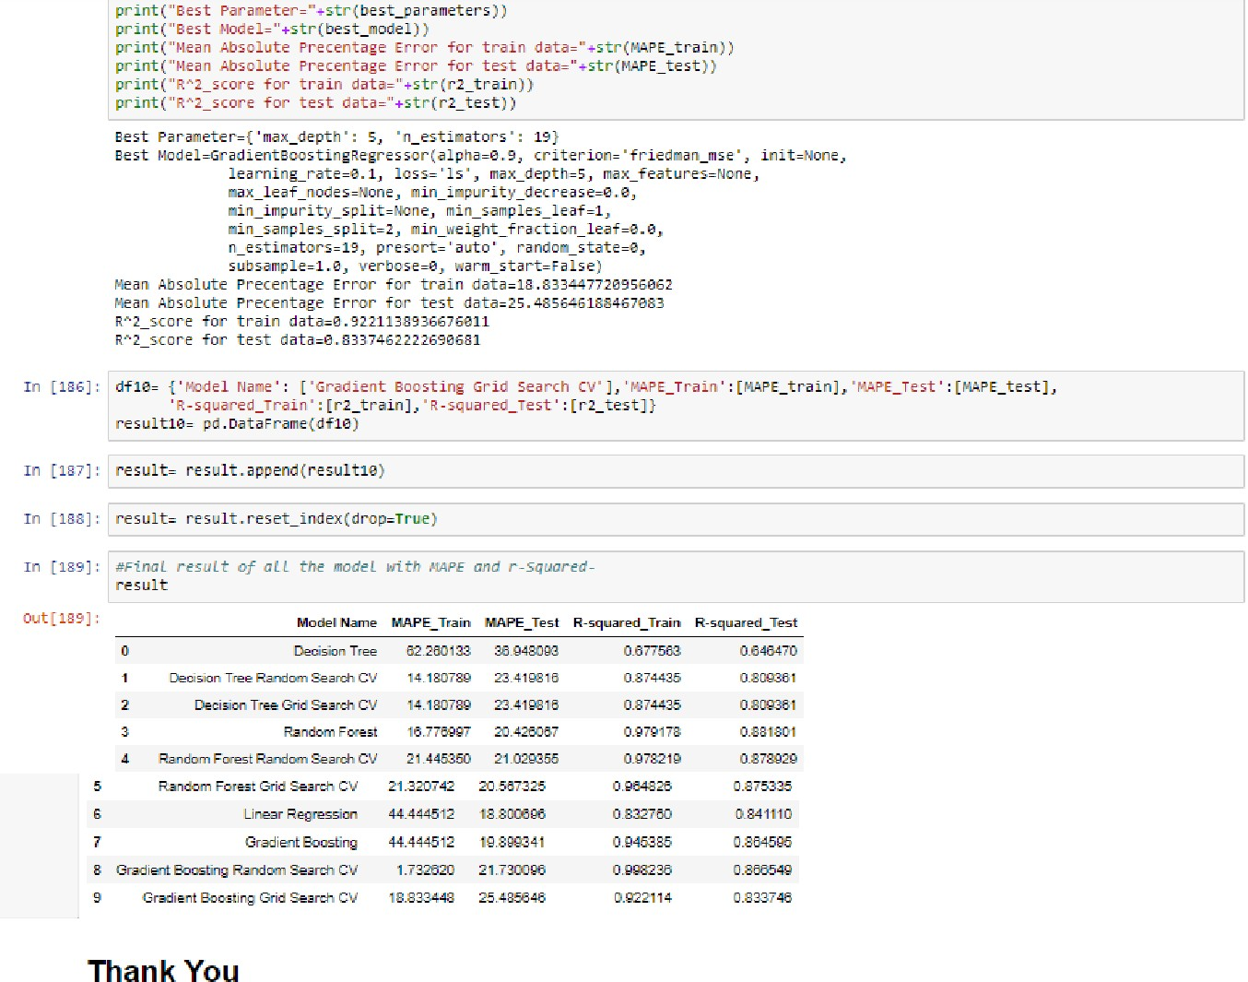

THANK YOU